

**Server & Cloud Security**

&yX:Q:w$x5{=x'|

**SCHOOL OF INFO COMM TECHNOLOGY**

Diploma in Cyber Security & Forensics

Diploma in Information Technology

**INDIVIDUAL ASSIGNMENT**

**Duration:** Weeks 5 -16

**Weightage:** 20% out of Total 40%

**Tutorial Group: T02 Grade: _______**

|  |  |
| --- | --- |
| **Student Name** | **Student Number** |
| 1. Dominic Lee | S10222894 |

**Deliverables**  
You should demonstrate that the file server and security tools configured are functioning and produce a detailed report with the following details and necessary screenshots:  
• Procedures of setting up a file server with connection testing results;  
• File server hardening approaches and implementation results;  
• Explain the key functions / features of the proposed security tool(s);  
• Install, configure the tool(s), prepare test cases, and perform testing & evaluation of  
the tools;  
• Any other good practices implemented to secure the file server (if applicable).

Table of Contents

1. Procedures of setting up a file server with connection testing results 3

2. File server hardening approaches and implementation results 11

3. Explain the key functions / features of the proposed security tool(s) 31

4. Installation and configuration of the tool(s) 34

4.1 Test cases and perform testing & evaluation of the tools. 41

5. Other good practices implemented to secure the file server 46

# 1. Procedures of setting up a file server with connection testing results

**1. Creating a MS1 user account in the scs.com domain**

Using the domain controller, DC1, we created a user account that will be used to access the share folder. The MS1 user account created will accessed via the MS1 computer though it can be from any other computer. It will act as the client computer accessing the server.

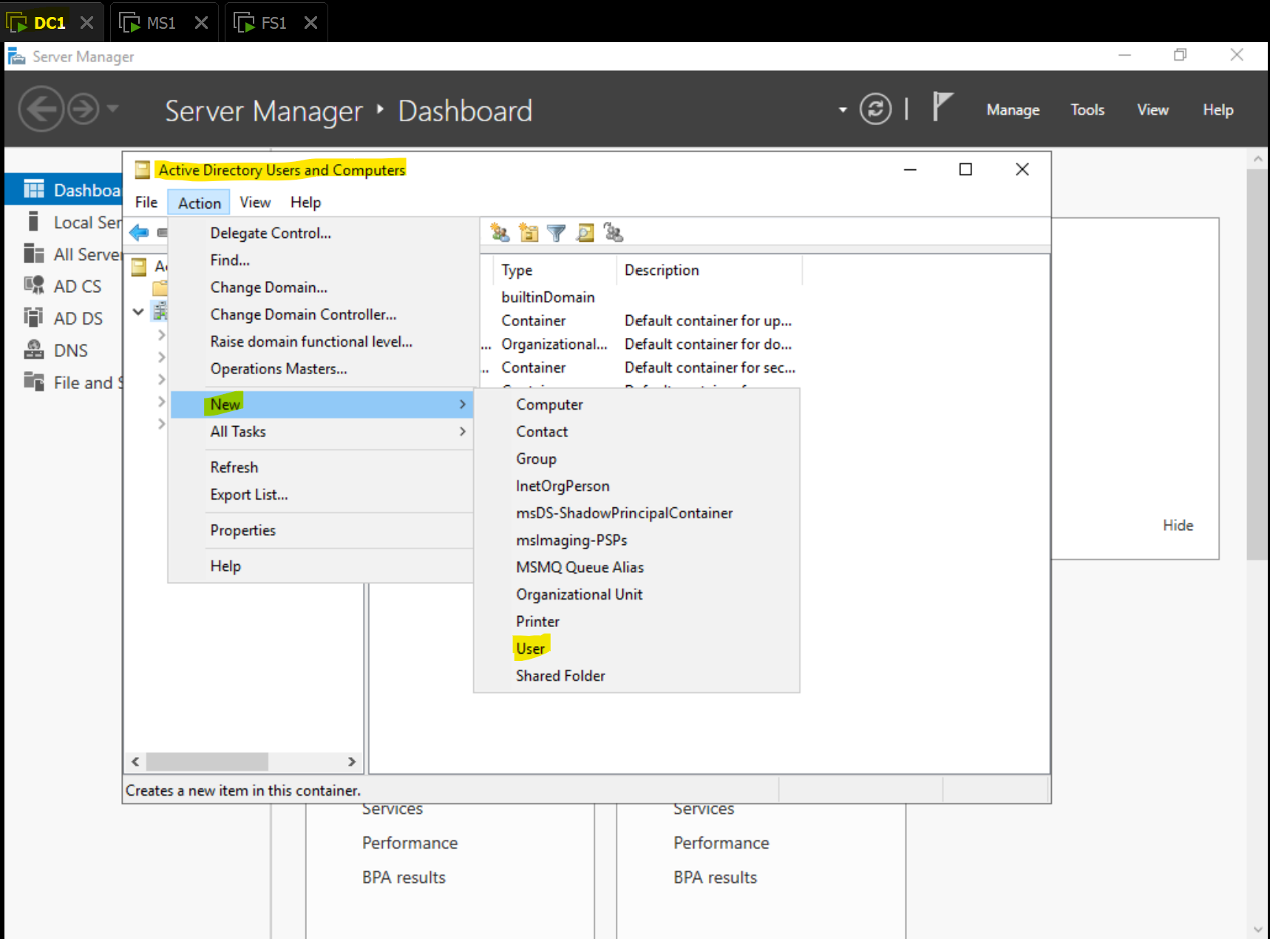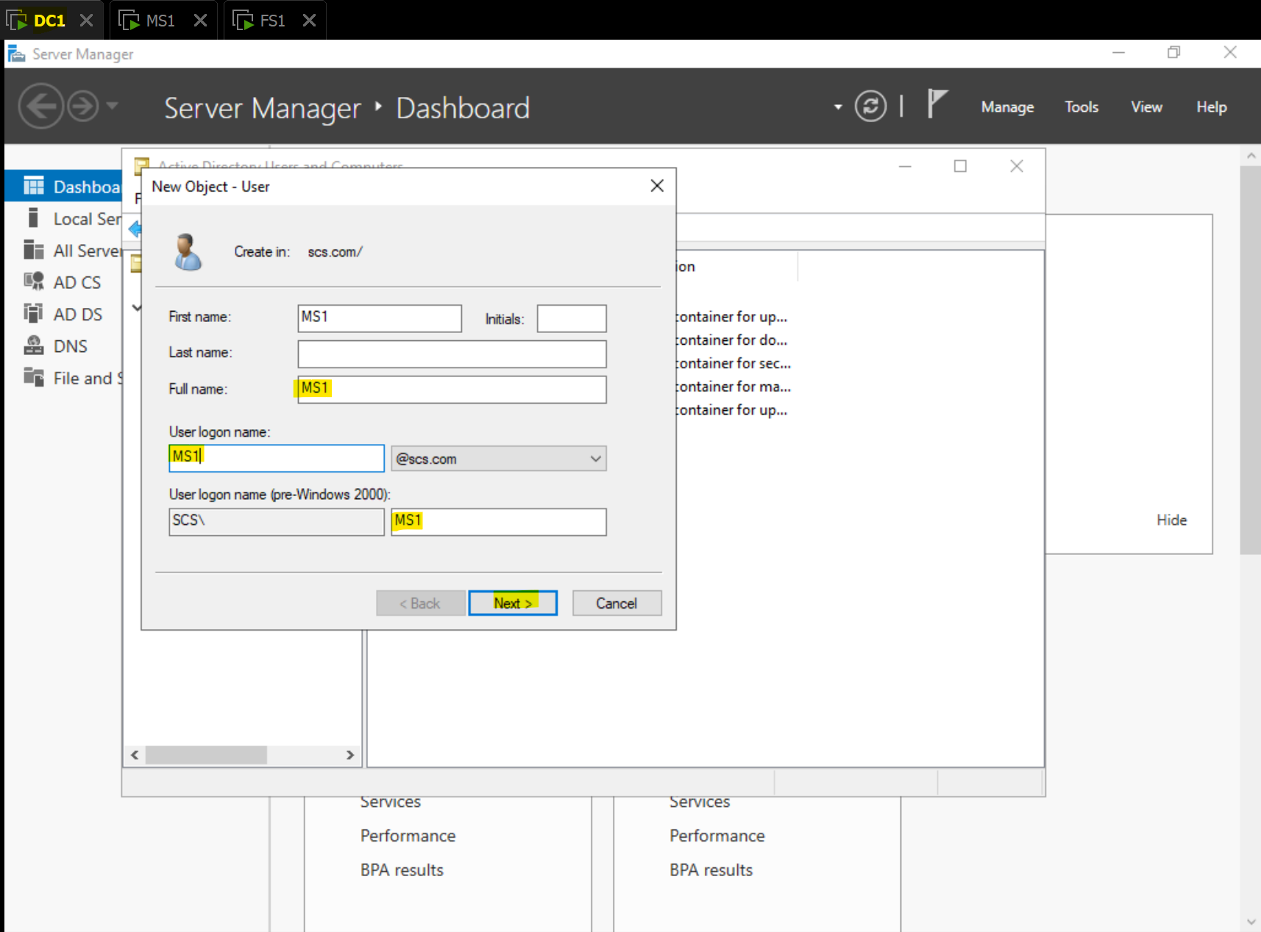

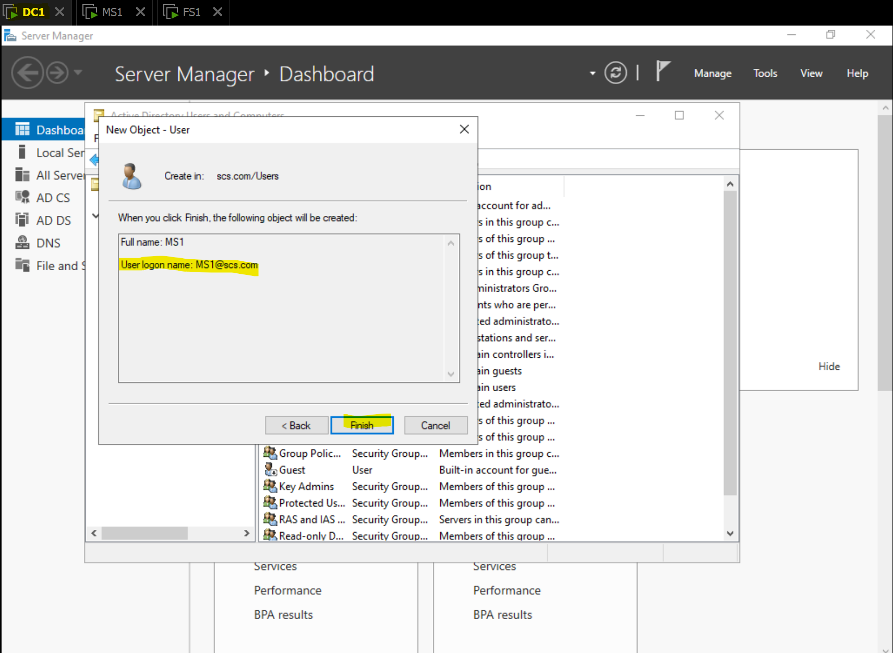

**2. Add File and Storage Services role to FS1**

This step should be done after adding FS1 to the domain MS1 is in. To add the file and storage service role to FS1, use the add roles and features wizard in FS1’s Server Manager to do so as shown below. *(** File server resource manager not strictly needed to make FS1 a file server, but used for server hardening purposes as described later)*

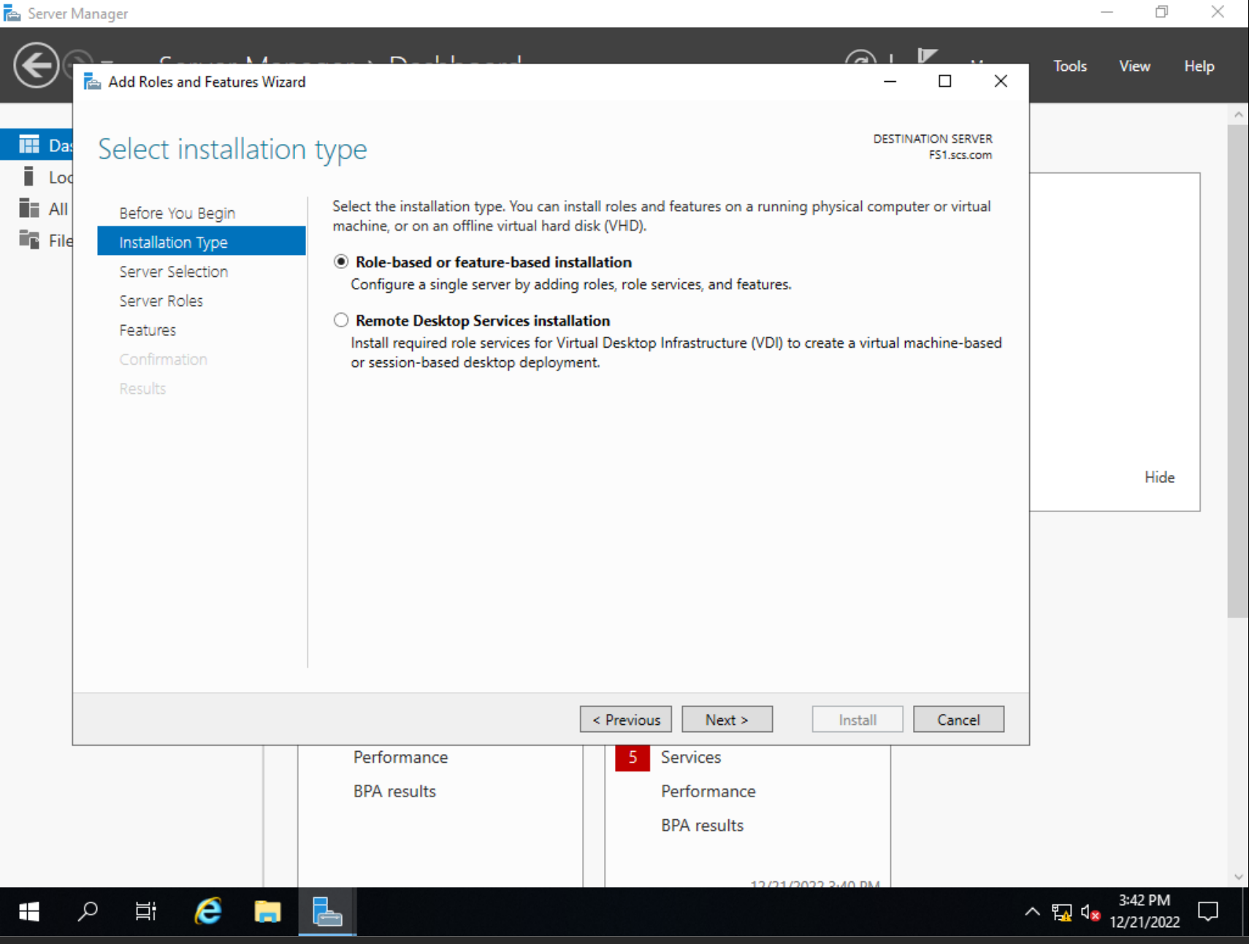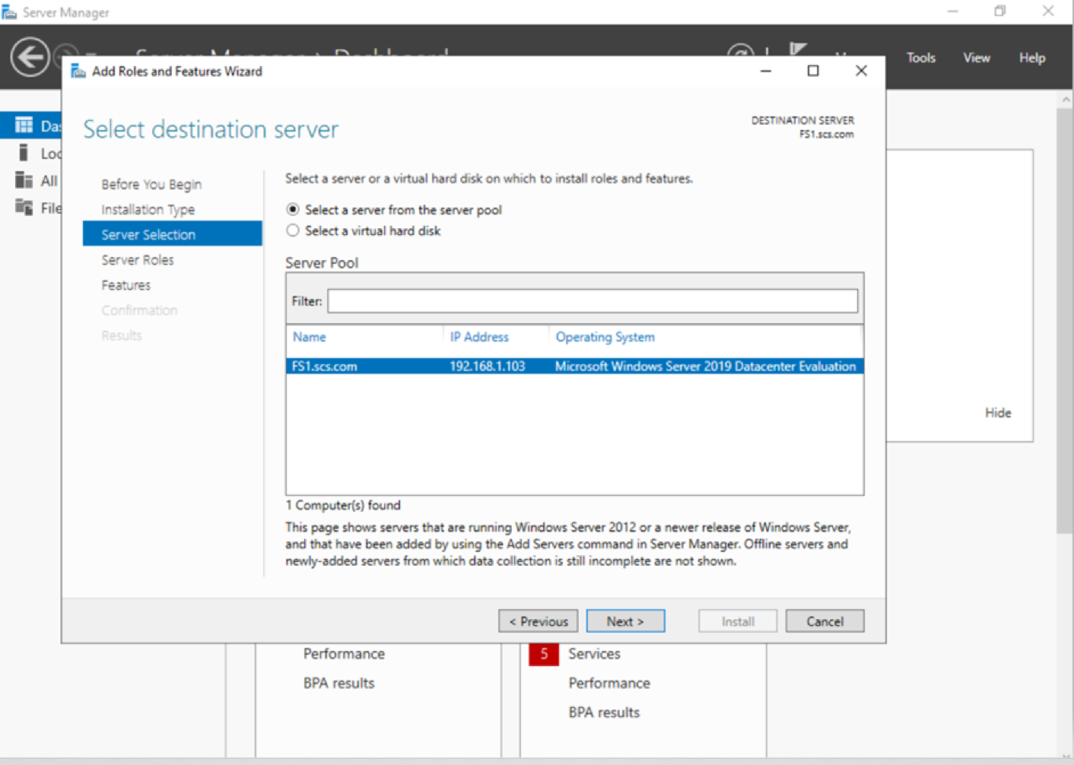

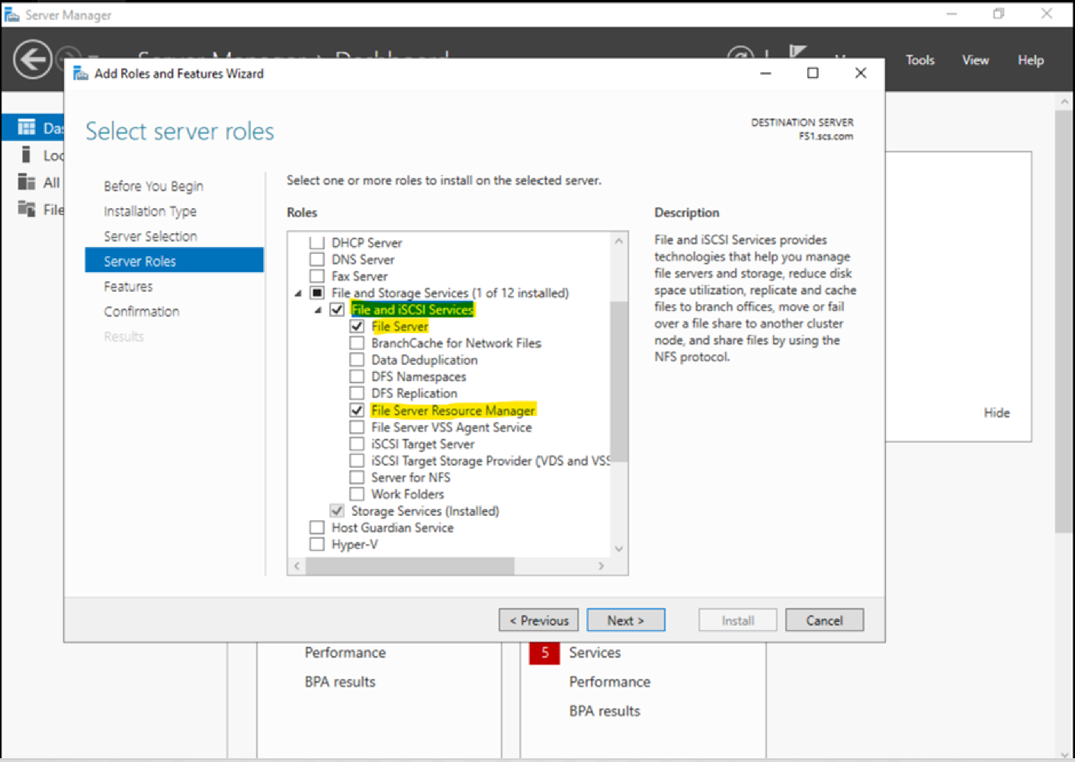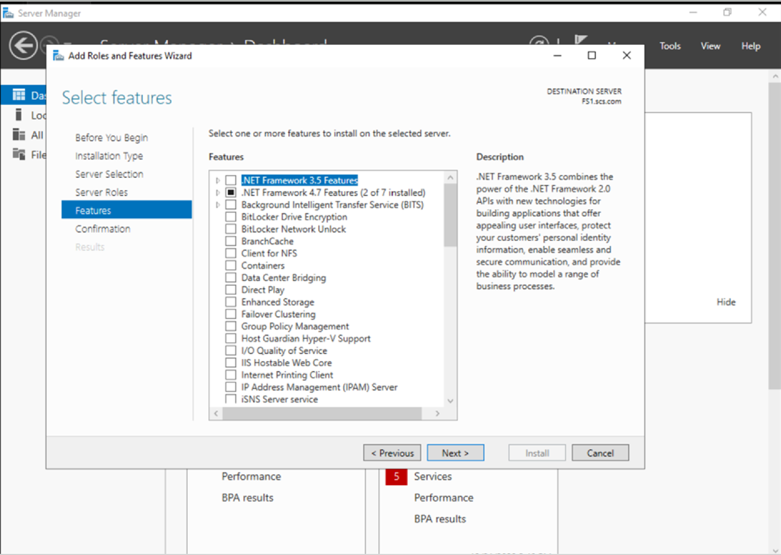

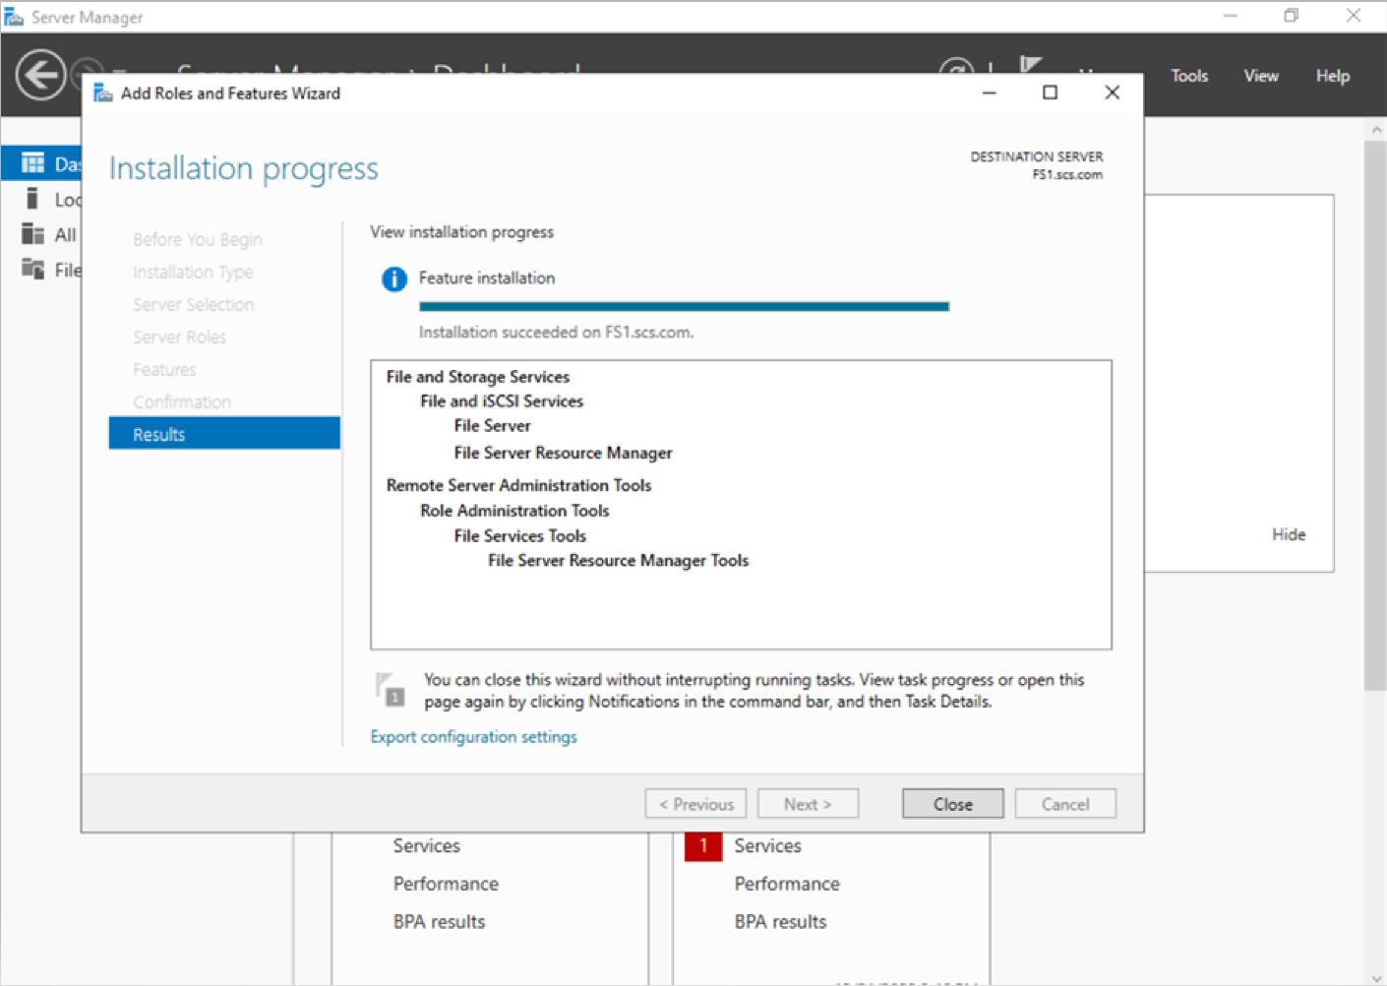

**3. Create a Share folder using the File and Storage Services**

In FS1, we will create a new share and specific parameters such as the name, location and configuration of the share settings. These were all left at their default values though they can be changed after the creation of the folder. This folder will be shared with and accessed through MS1 user account.

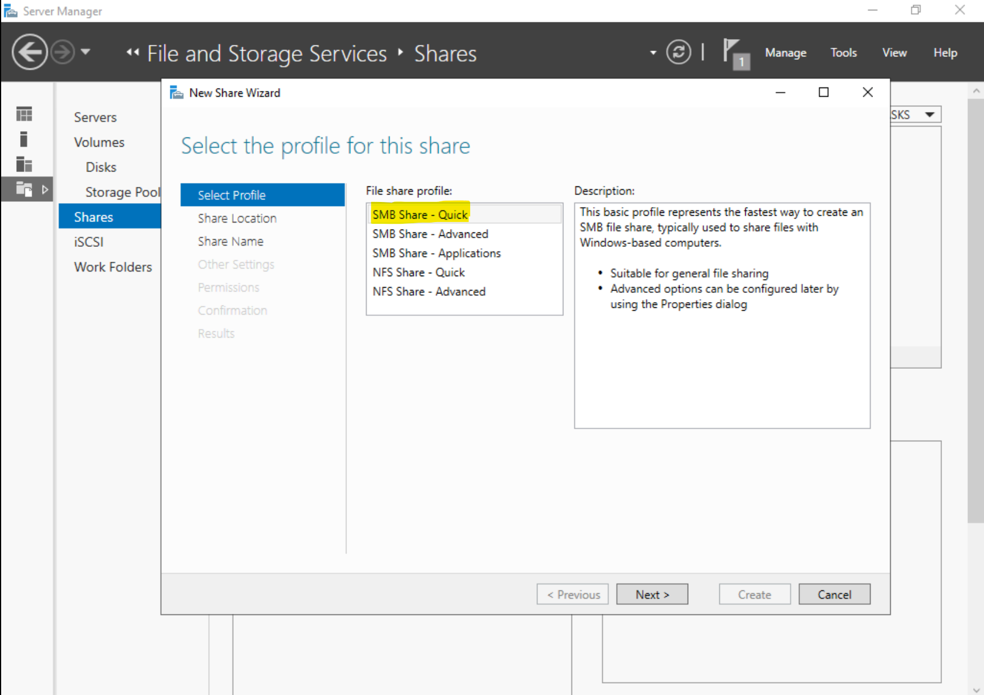

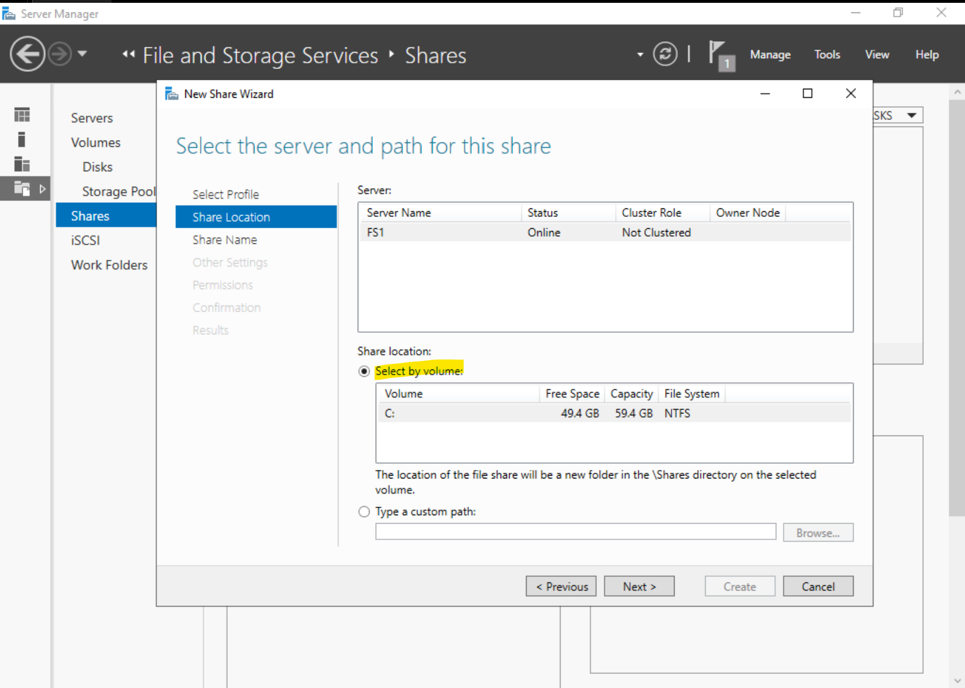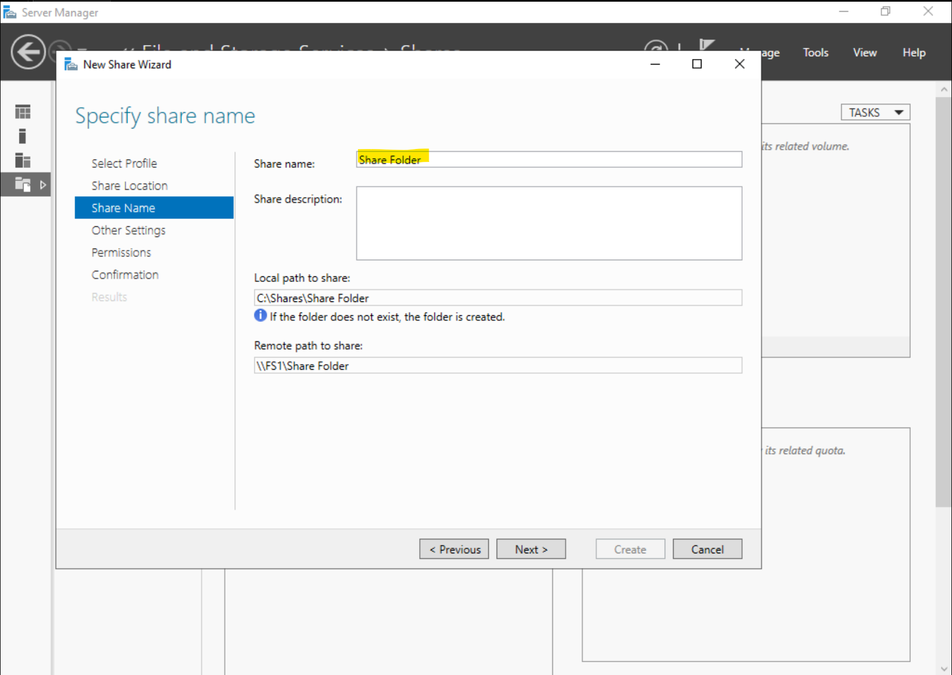

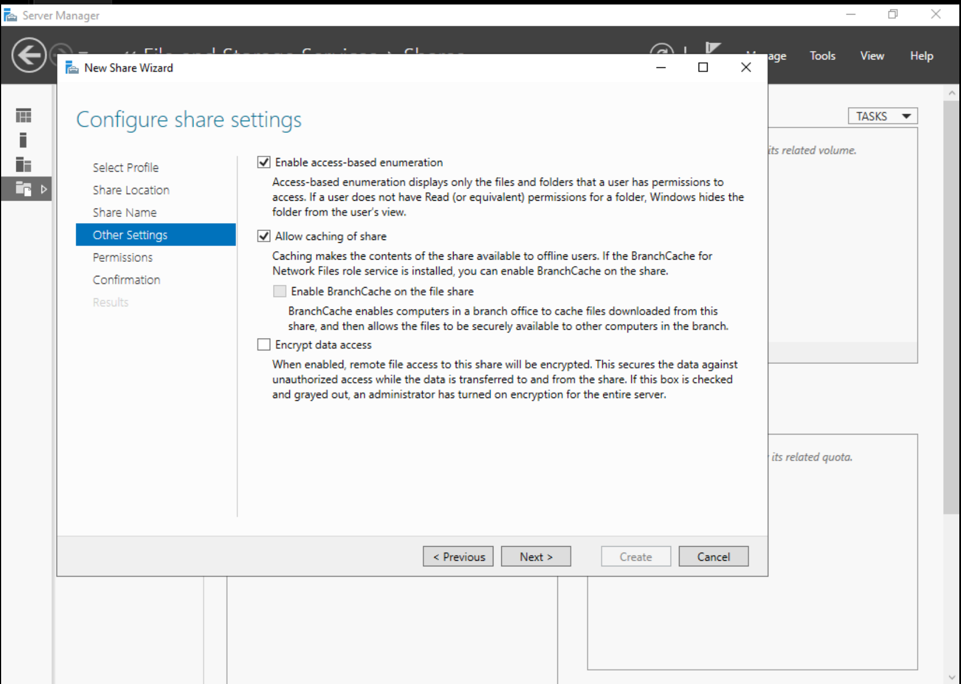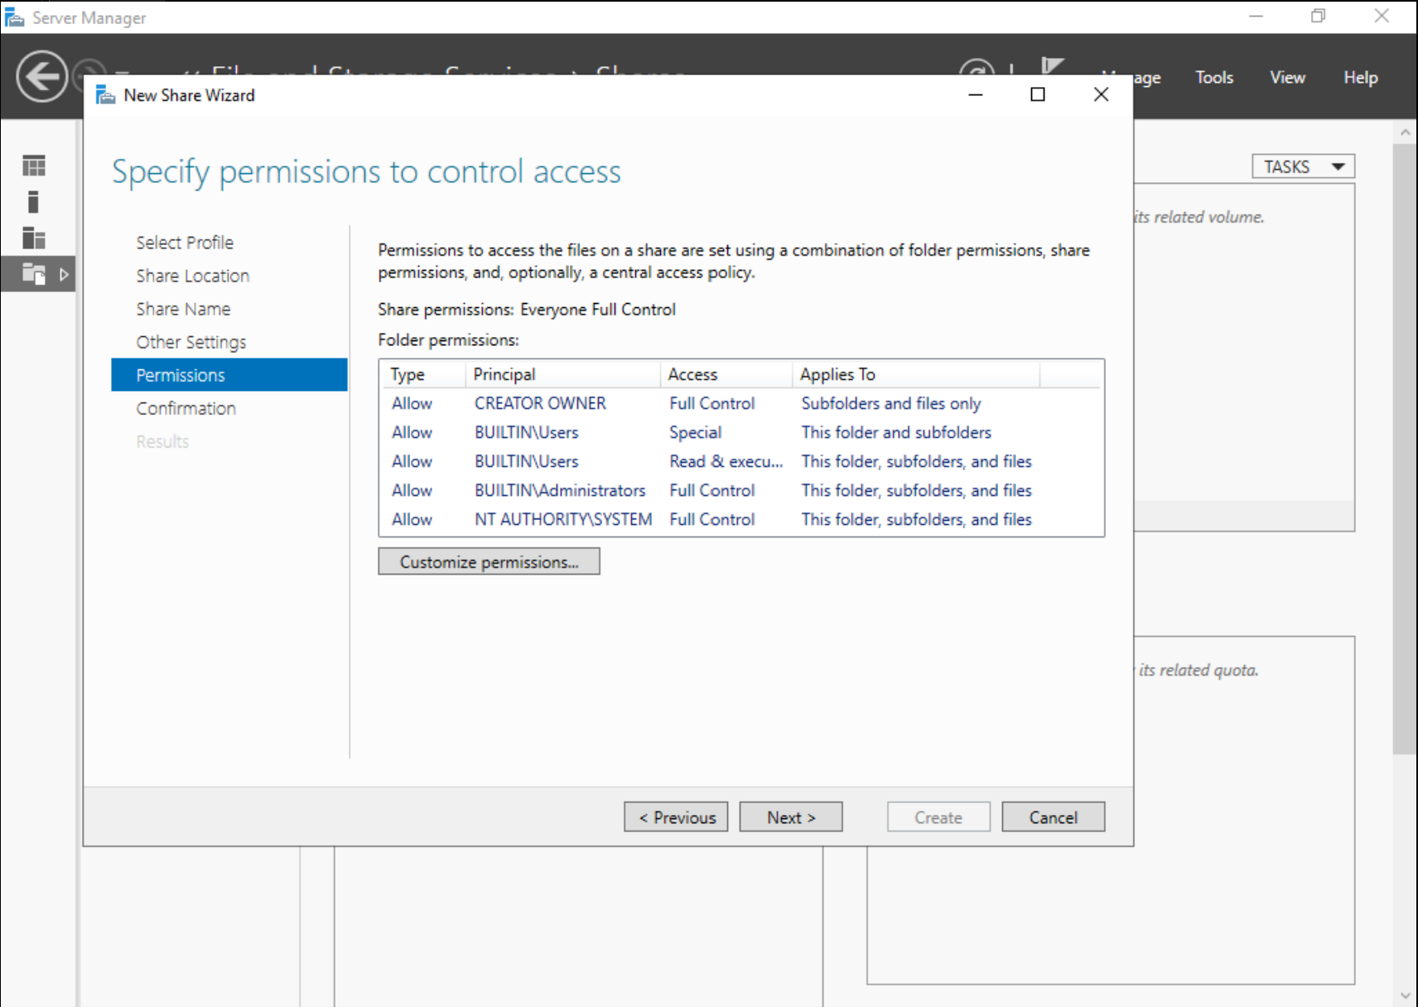

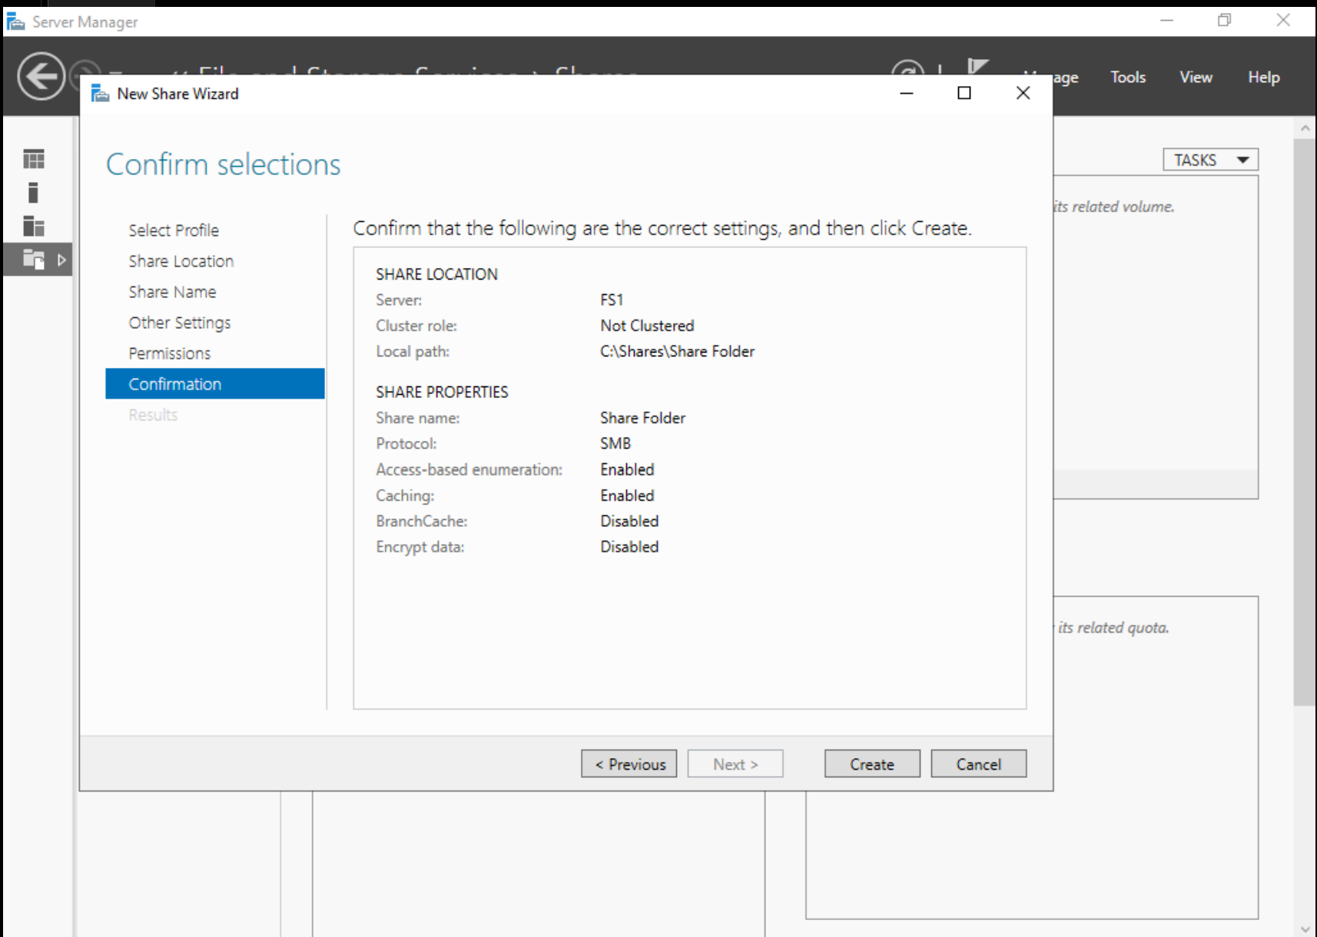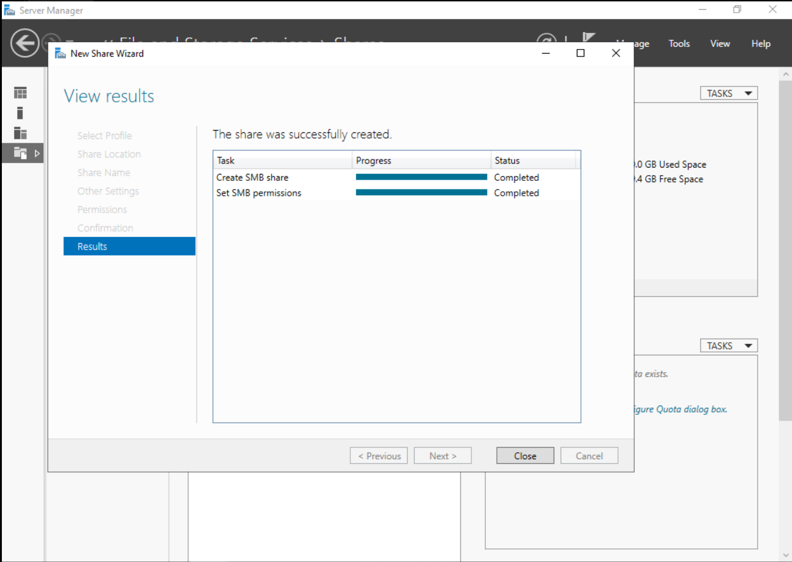

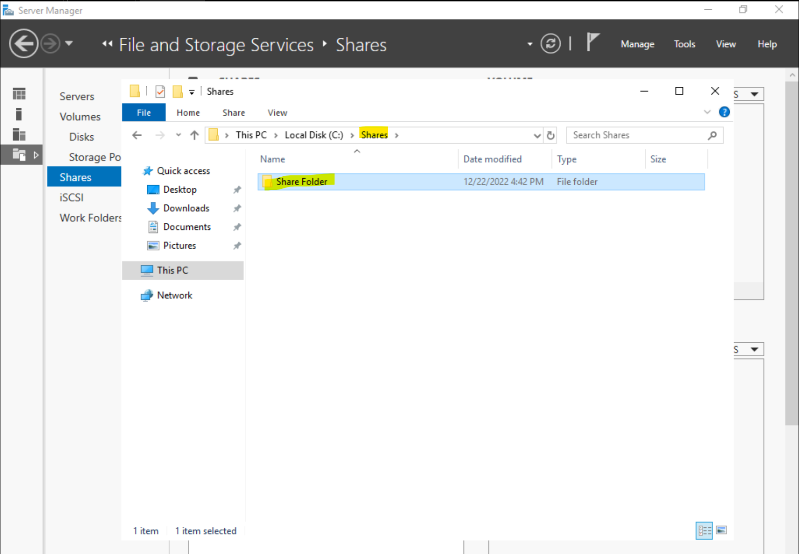

**4. Share the folder with Client**

After creating the folder, we must now specify that we want to share the folder with the user account MS1 user which we have done in the screenshots below.

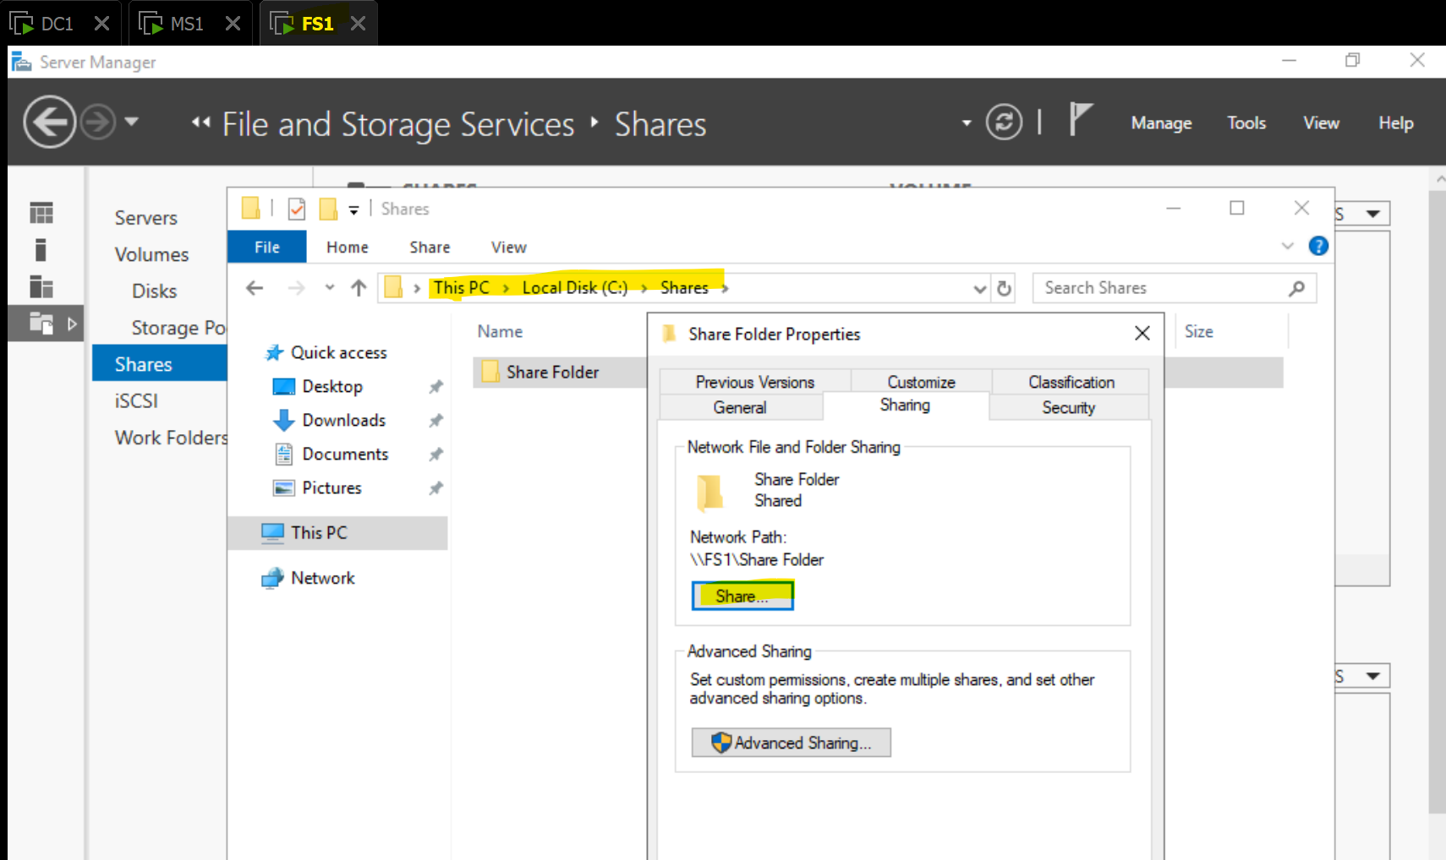

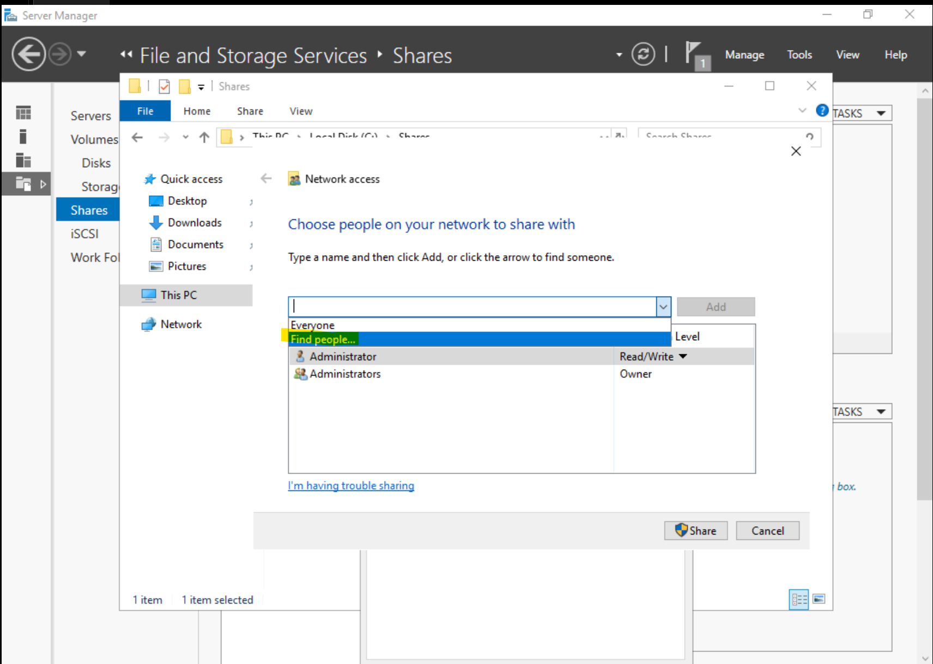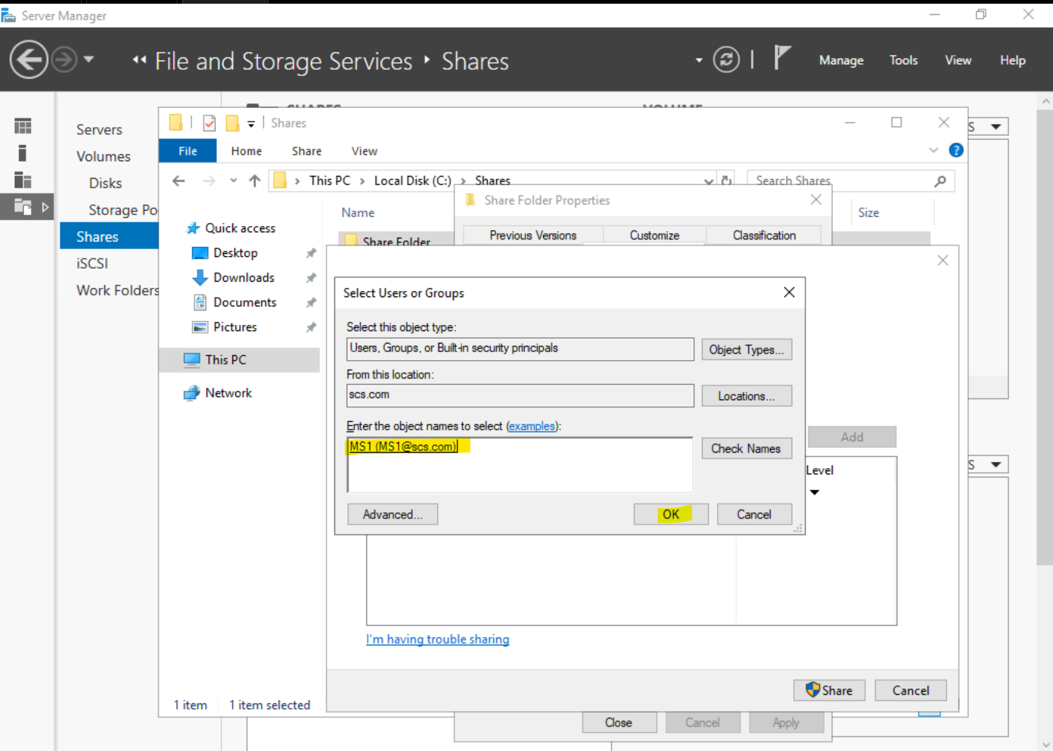

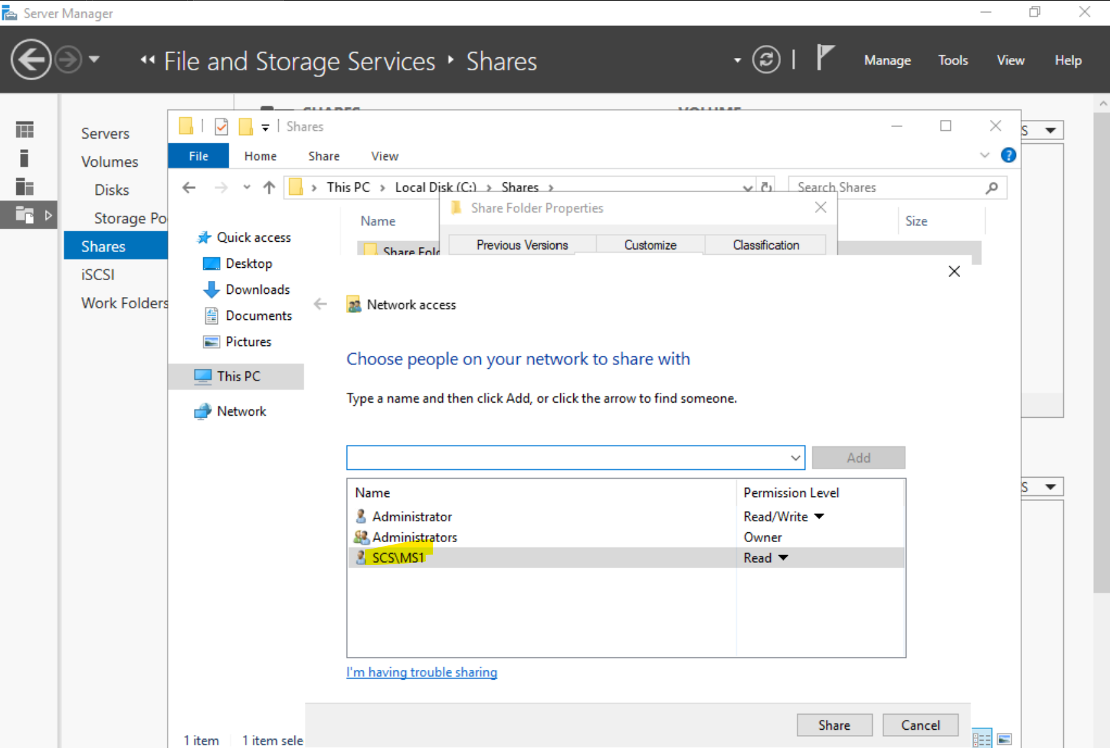

**5. Testing File Server Connections from Client**

Using FS1, a text file named ‘password.txt’ was created in the share folder. To test that the share folder was working as intended, we accessed the share folder using the MS1 user account. This was done by using the app called ‘Run’ where we inputted the share folder network path. As shown below, the MS1 user account can see the text file, ‘Password.txt’ even though the folder’s local destination is in FS1.

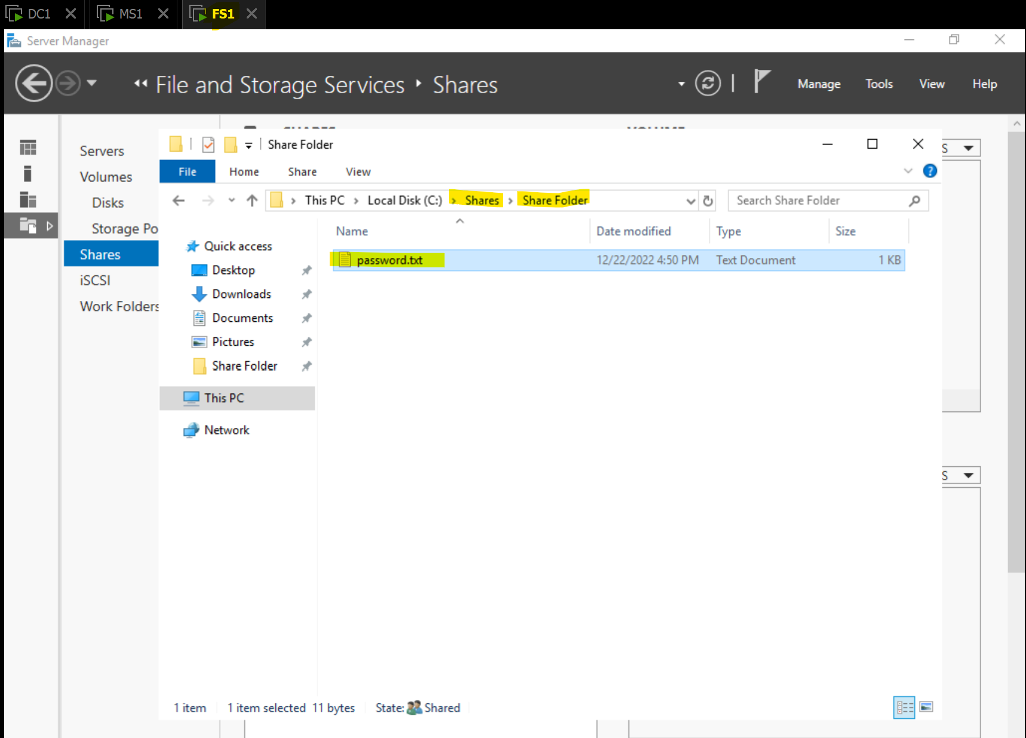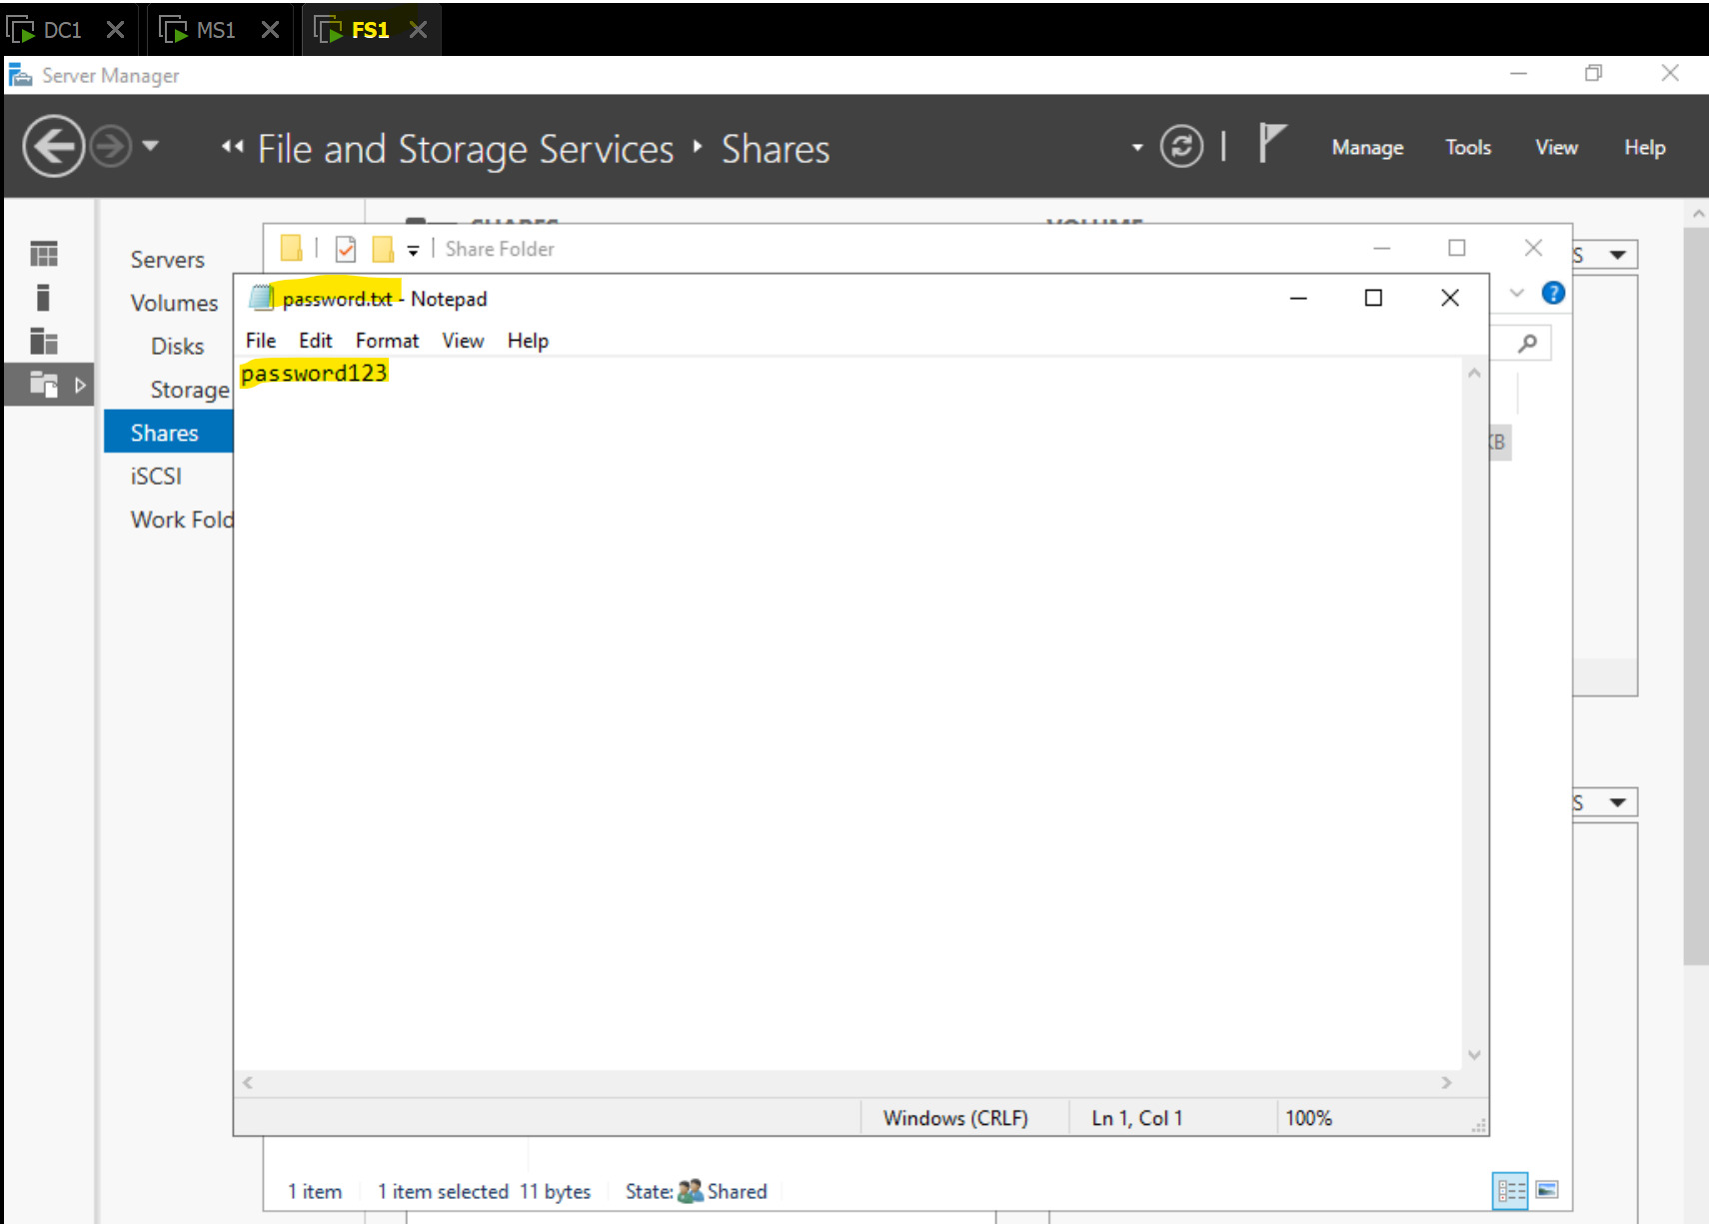

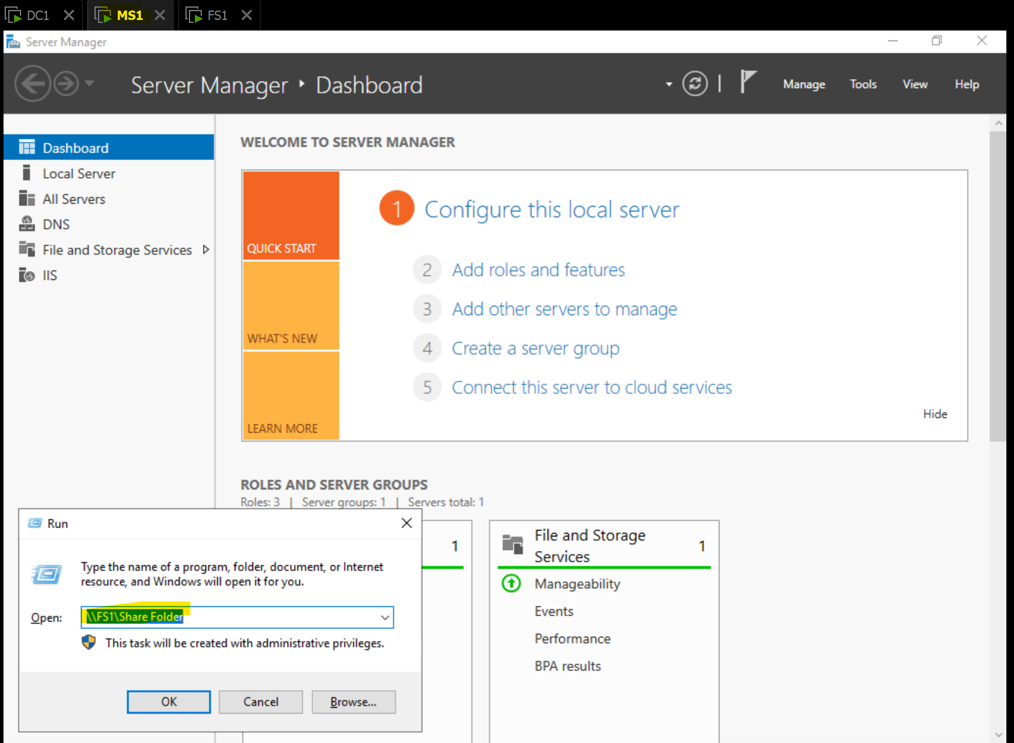

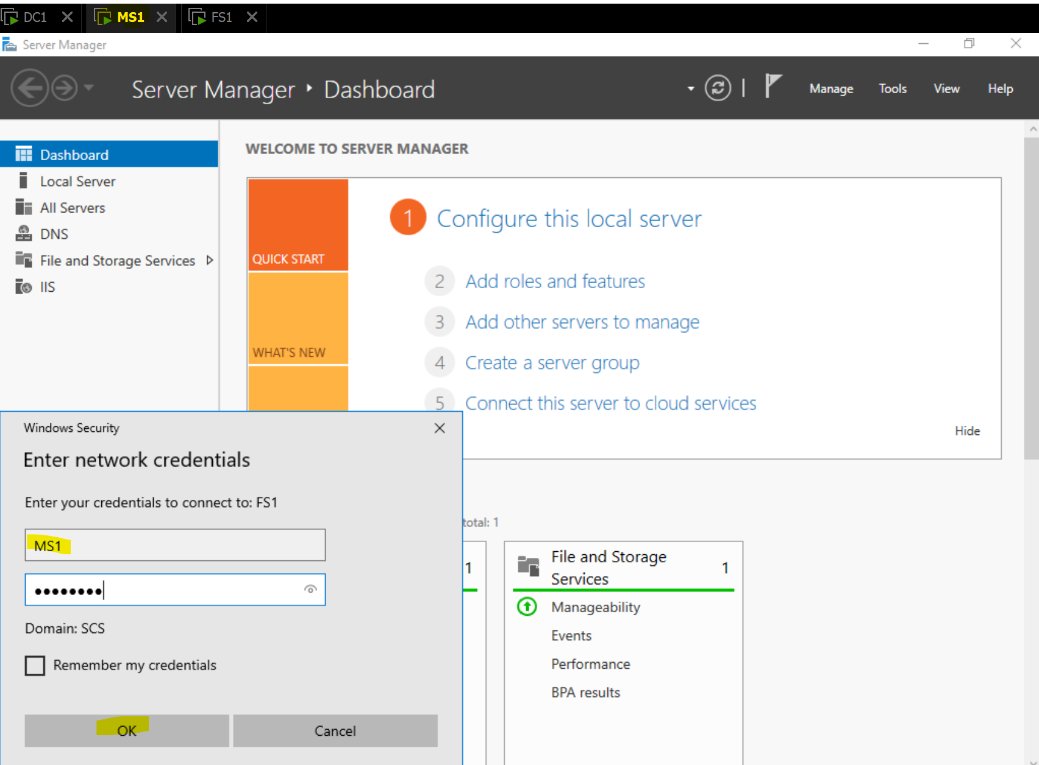

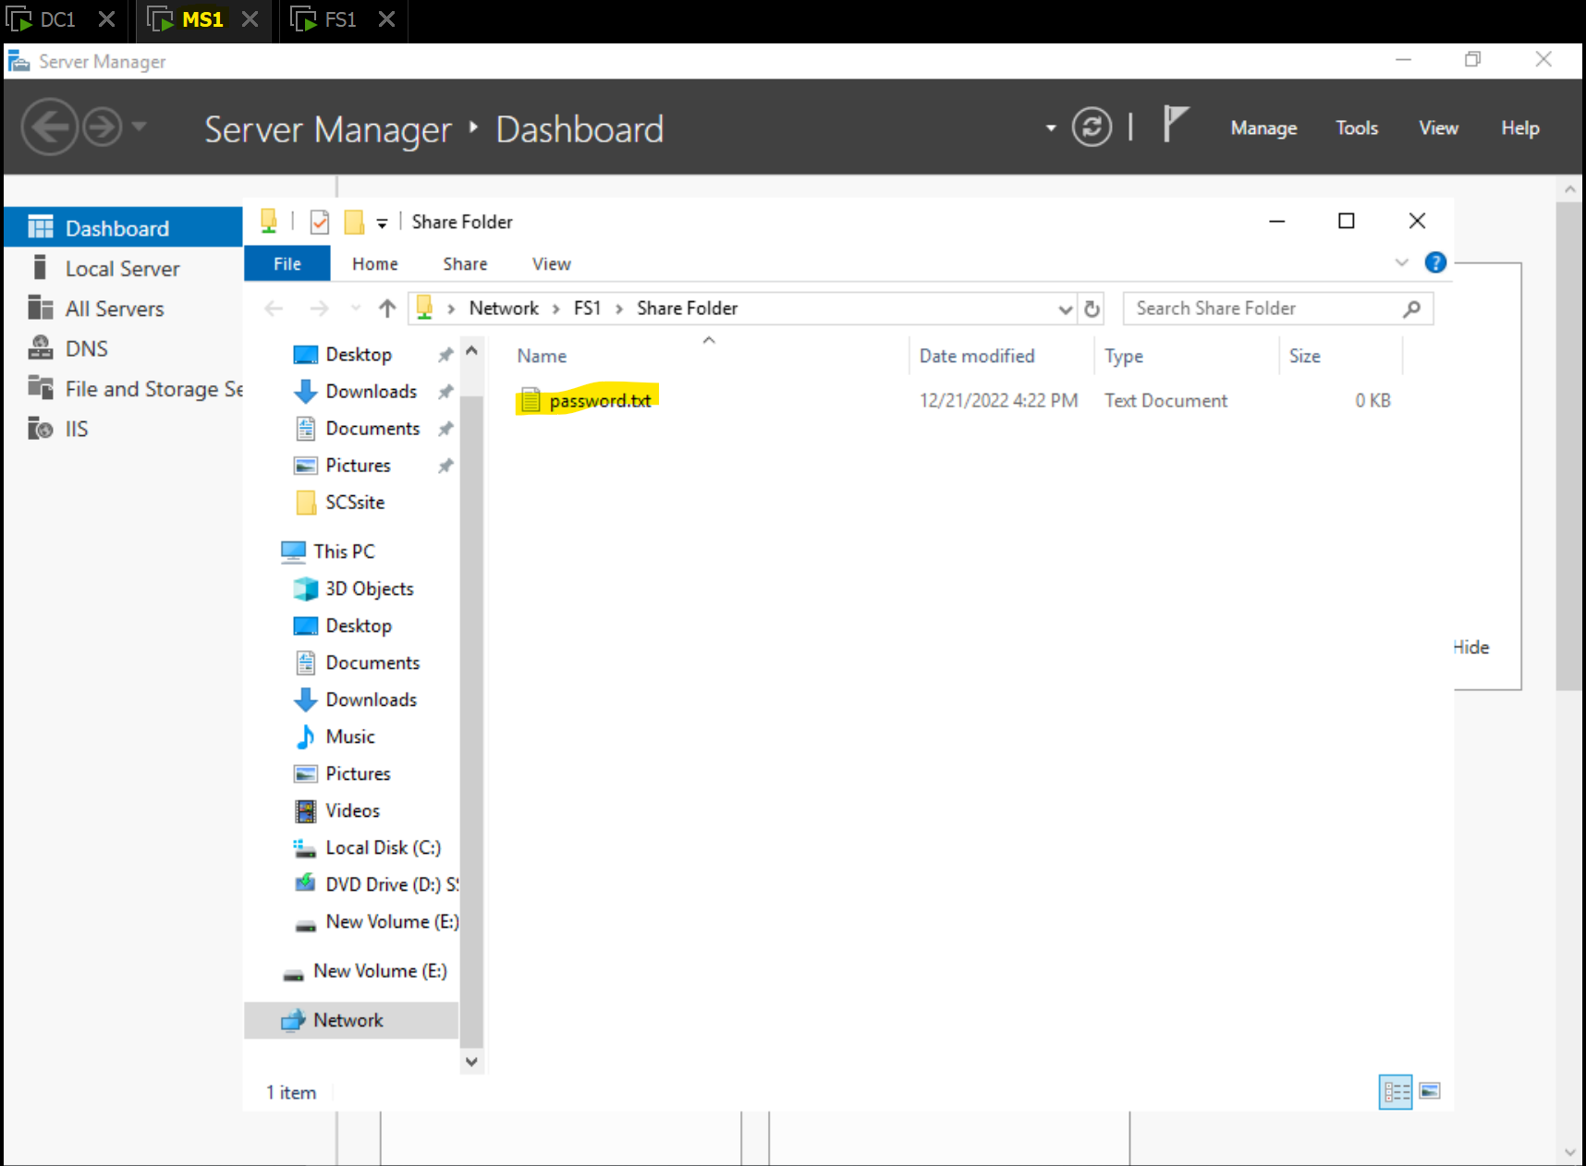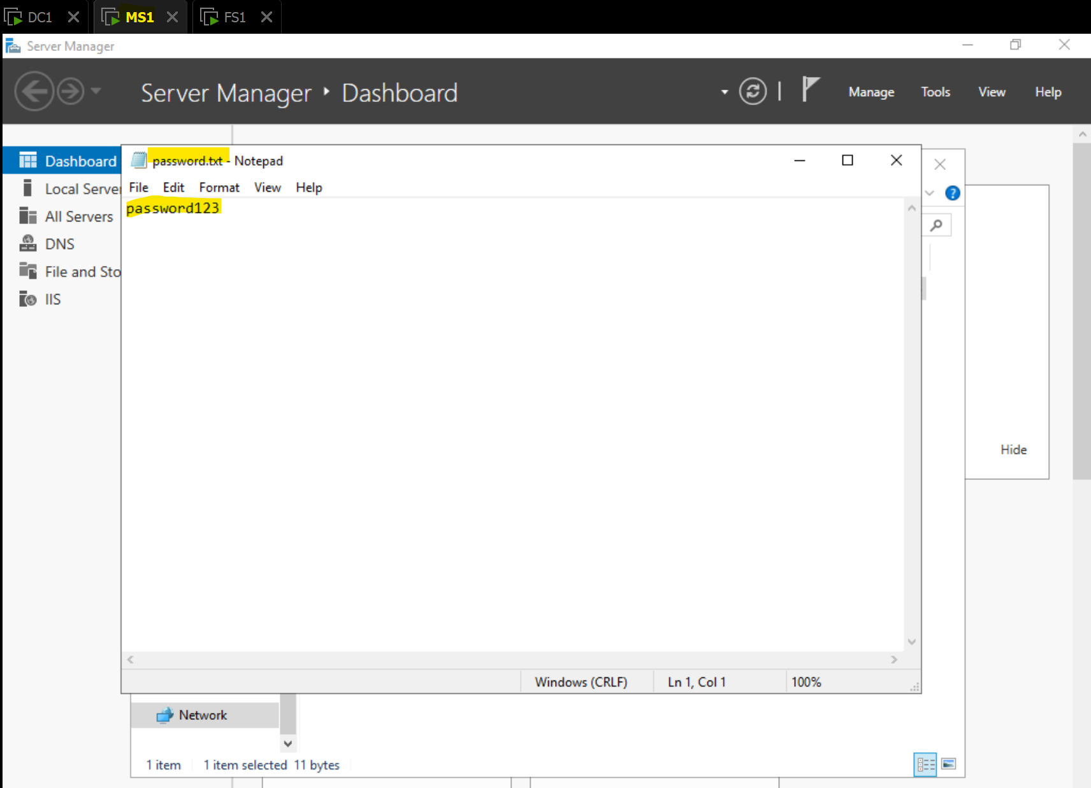

We have successfully finished setting up the file server, by installing the required roles needed as well as ensuring that the file server is connected to the domain controller and has connectivity to a user account, MS1 in this case, indicating connectivity.

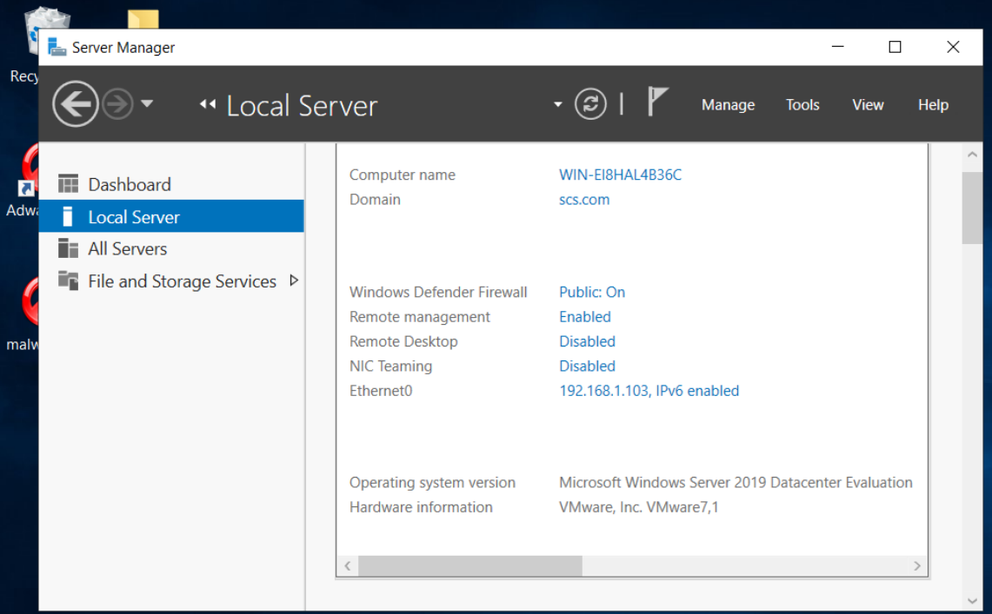

We see that the file server is conntected to the domain scs.com, with an IP address of 192.168.1.103.

# 2. File server hardening approaches and implementation results

**Server Hardening through EFS**

The file server was hardened by implementing EFS.

EFS (encrypting file system) is a feature that allows users to encrypt files and folders to protect sensitive data from unauthorized access. When a file or folder is encrypted, the content stored will be encrypted and can only be deciphered with the right decryption key. This provides an extra layer of security as attackers will cannot access the data even if they have access to the files, since the files are encrypted. This improves the confidentiality of data stored on the file server.

Furthermore, the encryption and decryption process is transparent to the user, hence the user will experience no difference then if the user were to access an unencrypted file or folder.

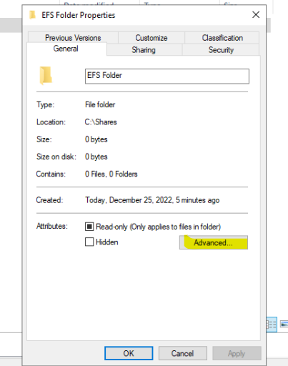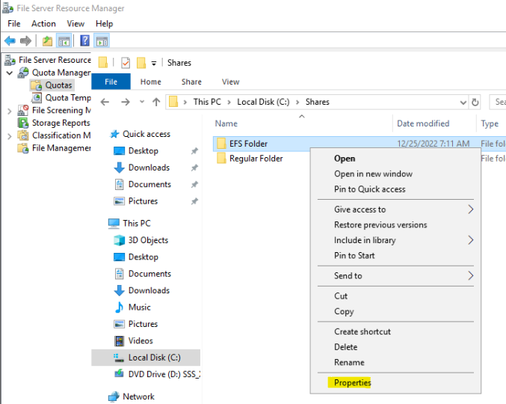

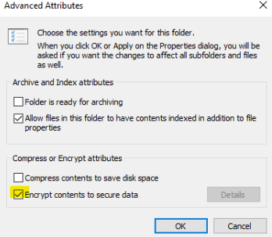

Go into the propeties of the folder, under general click advanced and check the checkbox which says “Encrypt contents to secure data”.

Following the steps above, EFS would have been implemented on the selected folder. The steps below will improve the quality of life by allowing users to easily identify which folders are encrypted using EFS.

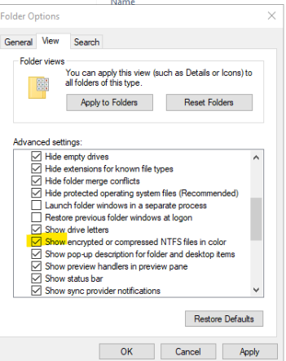

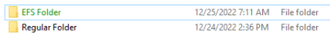

Here we see EFS folder is green indicating that EFS encryption is implemented while a regular folder is not.

EFS ensure confidentiality of data as it encrypts the data that is inside it. Meaning if a folder has EFS configured for it, then all its files would be encrypted which improves confidentiality.

**Secure the Network**

To secure the network, IPSec and Windows firewall were configured to secure and block traffic. First, there will be a firewall rule created on the file server (FS1) to block all ICMPv4 echo request. Then, an IPsec rule will be used to enable secure communication between the domain controller (DC1) and the file server. This means that after configuration, the file server will only be able to receive pings from the domain controller and not from any other computers.

By encrypting or authenticating every IP packet in a communication session, the IPSec (Internet Protocol Security) suite of protocols secures Internet Protocol (IP) communication. For transferring data over an untrusted network, like the Internet, IPSec offers end-to-end security. It can be used to safeguard a number of IP-based applications, including traffic using IPv4 and IPv6. The Network Layer (layer 3) of the OSI model is where IPSec functions, protecting IP packets as they travel through the network.

Windows Operating systems come with a software-based firewall called Windows Firewall. Its purpose is to protect against malicious access to a computer by controlling incoming and outgoing network traffic. By allowing or blocking network traffic in accordance with rules that are established by the administrator or by the operating system itself, Windows Firewall offers fundamental protection against malicious traffic. Based on parameters like source and destination IP addresses, port numbers, and protocol types, the firewall can be set up to allow or restrict certain traffic

We will use both these tools to provide a comprehensive security solution for the network as Windows firewall provides security at the application layer of the OSI model (layer 7) and IPsec does the same at the network layer (layer 3).

IP address of VMs:

DC1 = 192.168.1.101

MS1 = 192.168.1.102

FS1 = 192.168.1.103

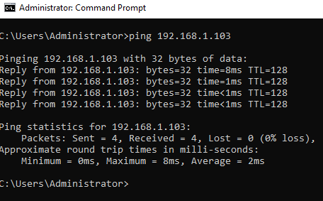

Initially, DC1 can ping FS1.

After configuring, the firewall rule “Block Ping”:

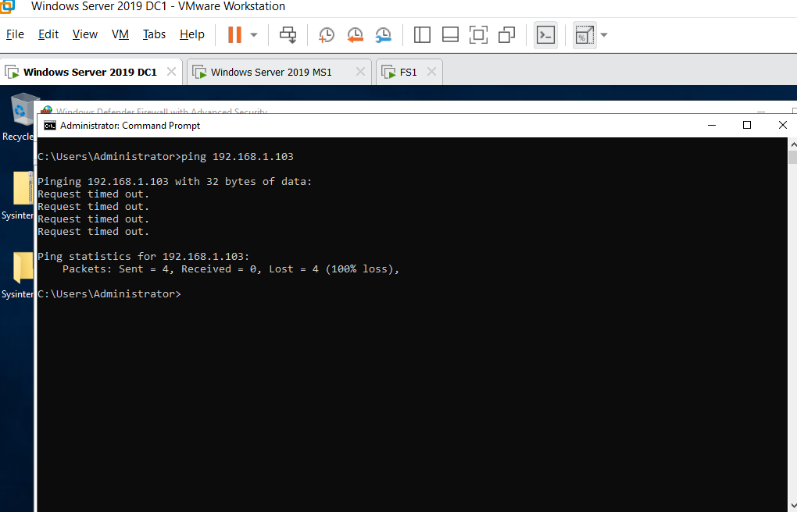

The ping packets are blocked, and it does not work anymore.

Below are the options chosen to configure the firewall rule on FS1.

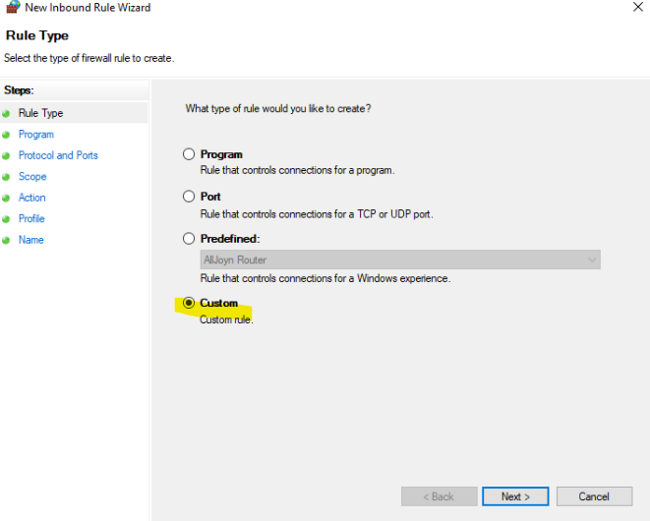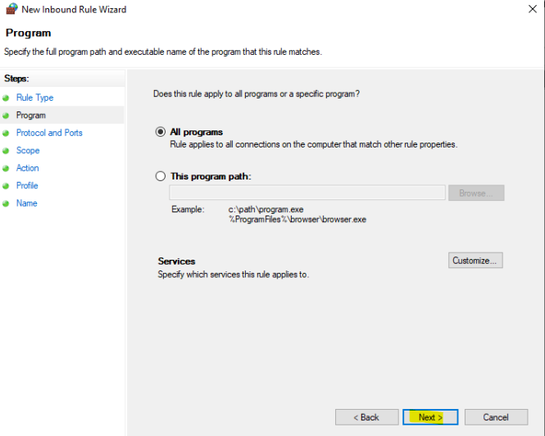

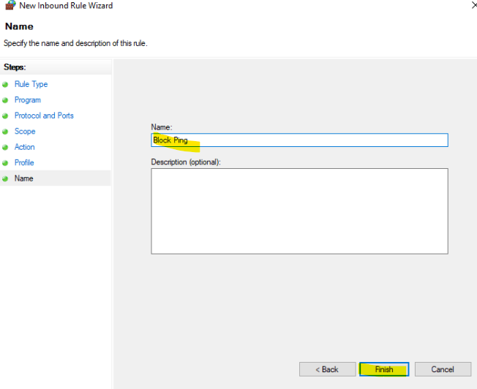

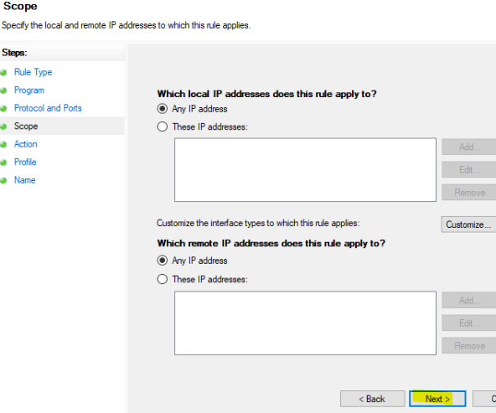

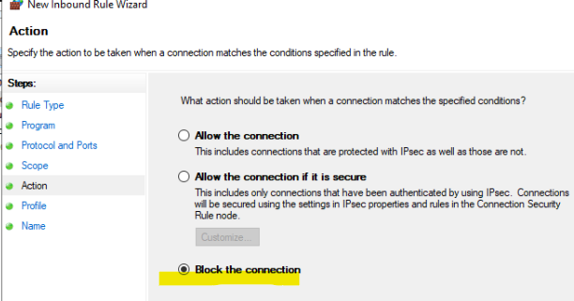

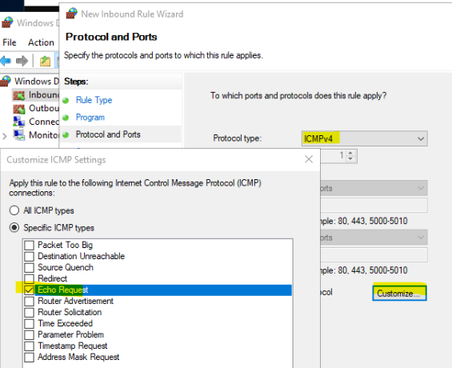

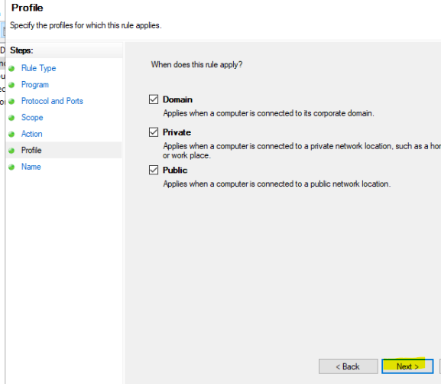

There are different types of rules to choose from, here we chose custom, followed by all programs, and blocking the connection of all IP addresses for echo requests on domain, private and public networks.

Next, we implemented IPsec rules to enable pings only between DC1 and FC1. We see that the IPsec rule overrides the firewall rule allowing DC1 to ping FS1 but MS1 is unable to. This is the expected result of the configuration.

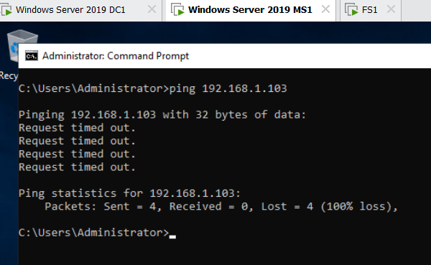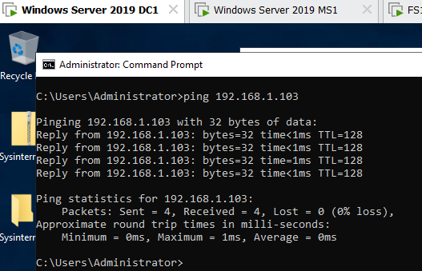

Steps in FS1:



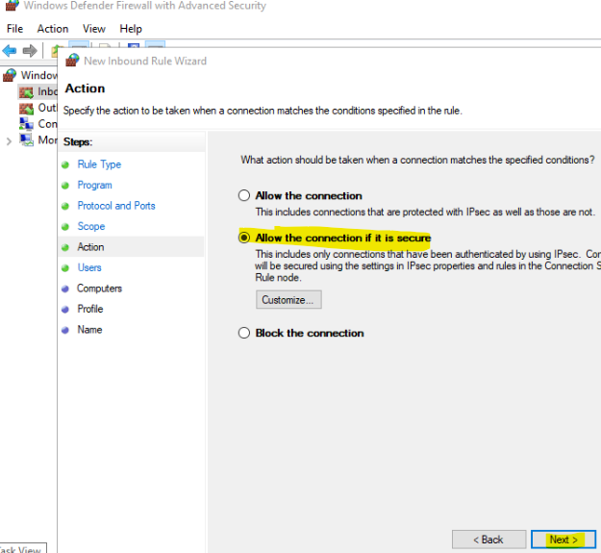



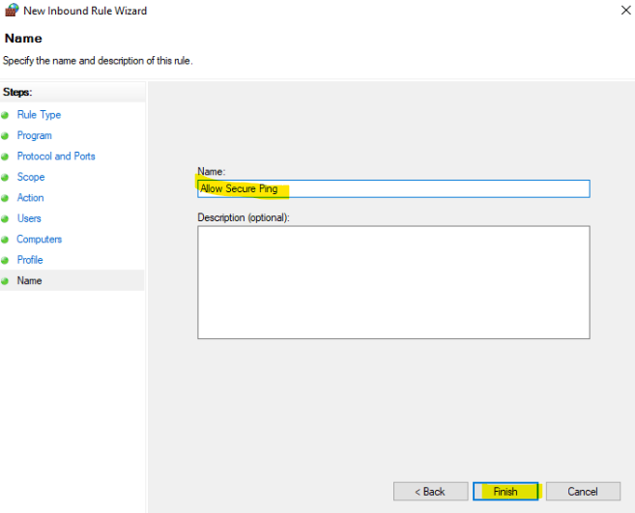

Steps in both FS1 & DC1:

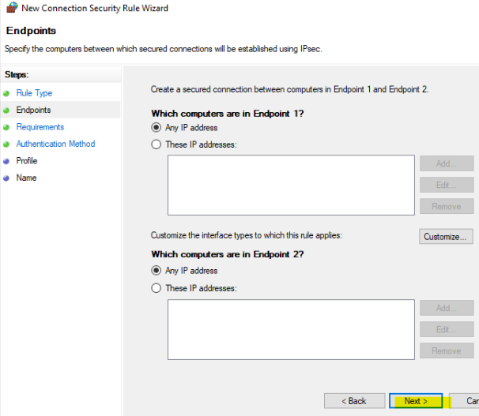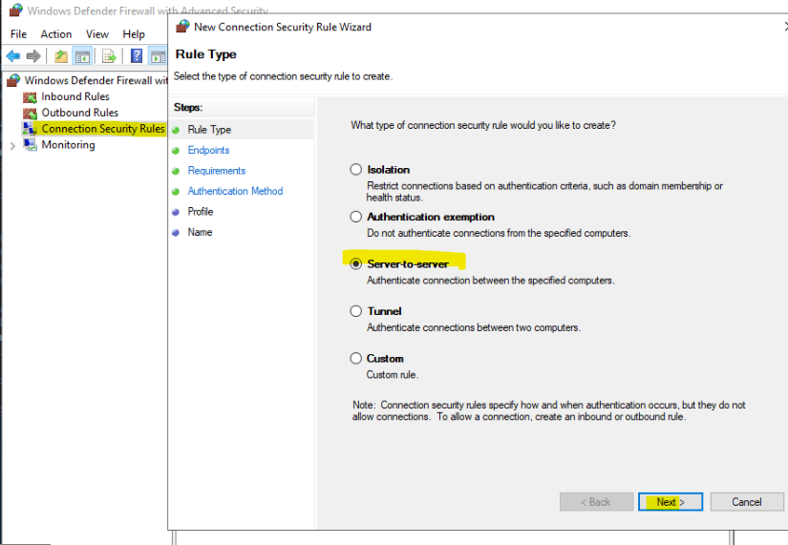

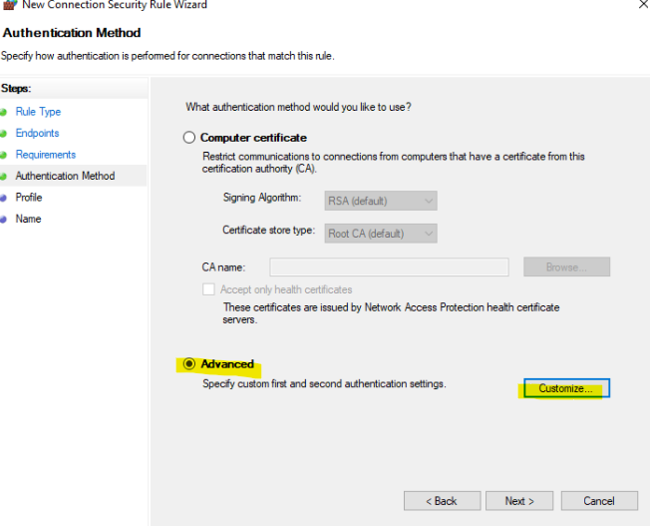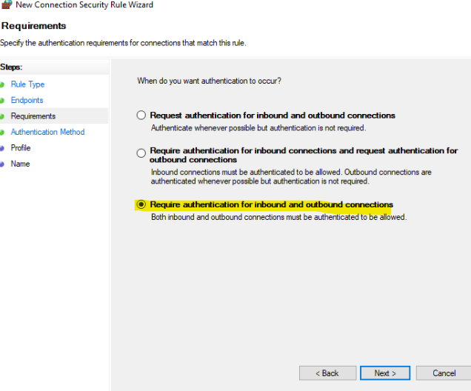

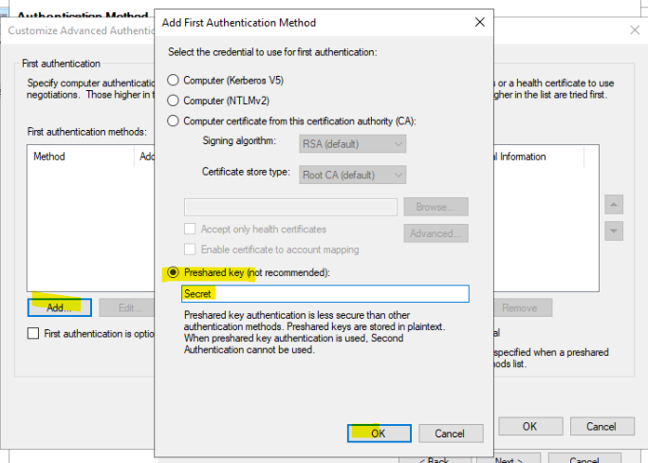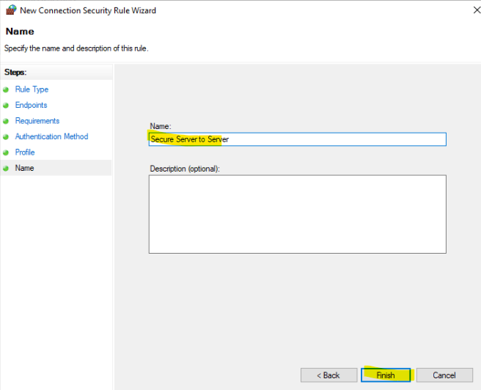

To conclude, we see that firewall rules and IPsec (Internet Protocol Security) are crucial security features that aid in defending networks and systems against unauthorized access and harmful assaults such as ping floods and ping of death.

By configuring these firewall and IPsec rules, we are able to better protect the server from malicious traffic and ensure that all traffic received is secure. This is especially important for a file server as the data stored on it might be highly confidential in nature.

**Secure File Services**

**File Quotas**

File Quotas are a feature in Microsoft Windows Server operating systems that allow administrators to limit the amount of disk space that a user can consume on a file server. File quotas can be used to manage disk space usage on a file server and to prevent a single user from consuming all available disk space, which could cause performance problems for other users. File quotas can be assigned to individual users or to groups of users, and they can be set to specific amounts of disk space or can be based on a percentage of the total disk space available on the file server.

File screening and quotas were created to secure file service on the file server. There will be a quota created that has a limit of 100 MB which will be assigned to a folder called “Password”. We will then attempt to exceed the file quota limit by adding another file and we should expect that this is not possible.

Steps to create quota template & quota:

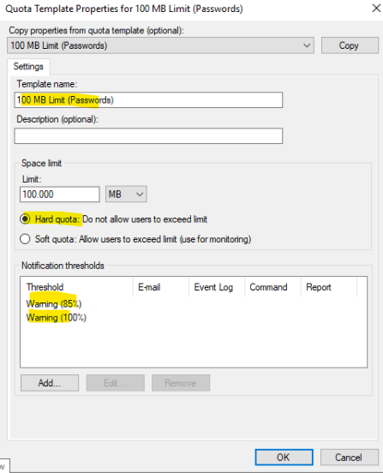

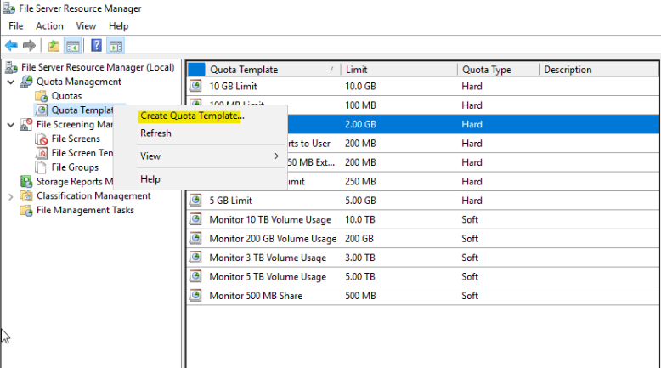

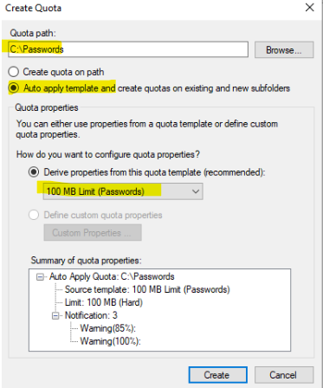

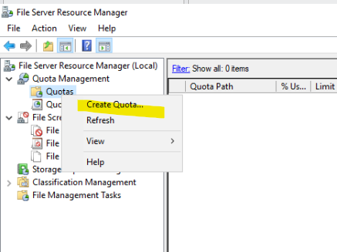

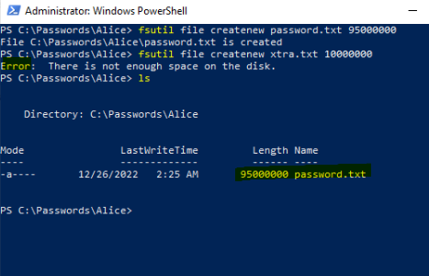

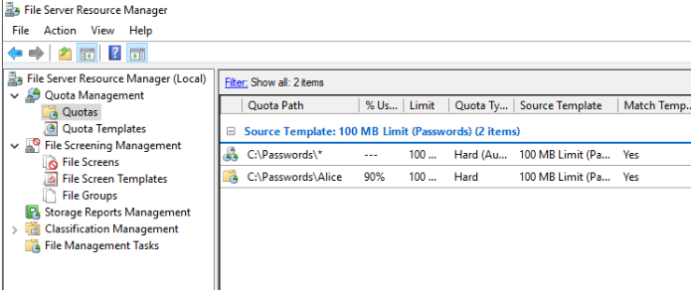

We can observe that the configuration is correct and that the file quota rule is working as intended. We created a file called password.txt that was almost the entire quota’s size and when we tried to add in another file, the operation failed as the total size of both files would have surpassed the quota’s limit.

This ensures that performance is not affected because too much storage is being used in the folder, keeping the avaialbility of the server secure.

Quotas are important as it ensure that users are not storing too much data in a certain location be it accidentally or maliciously. Attackers’ malware might be very large in size and by having quotas, it will disallow such malware to run. Also, if users store or use too much data, there might be availability issues and quota managements solve that.

**File screening**

File Screening is a feature in Microsoft Windows Server operating systems that enables administrators to control the types of files that are stored on a file server. File screening allows administrators to block or limit the creation of specific file types, such as executable files or script files, to prevent unauthorized users from storing malicious files on the server. This helps to ensure that only authorized files are stored on the server and reduces the risk of security incidents.

Steps to configure file screening for mpx files:

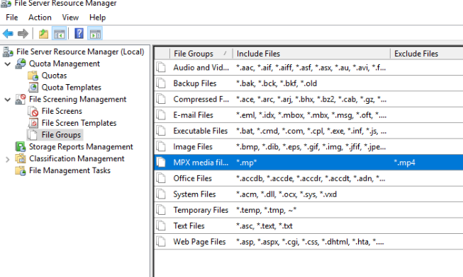

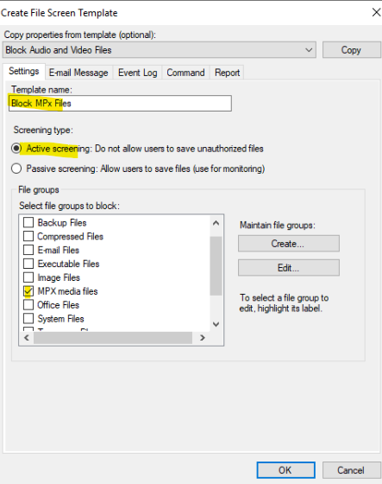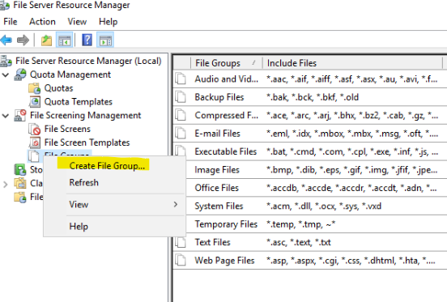

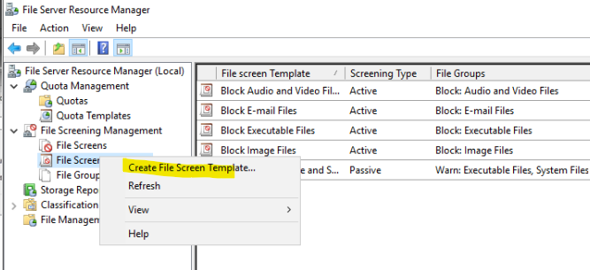

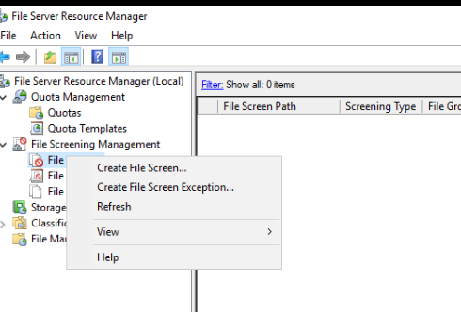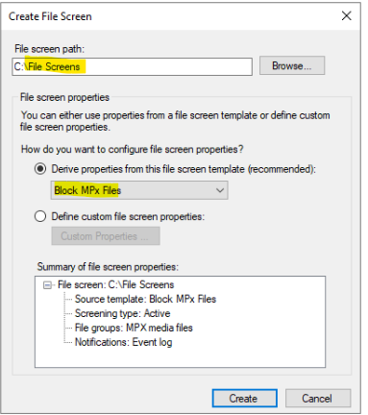

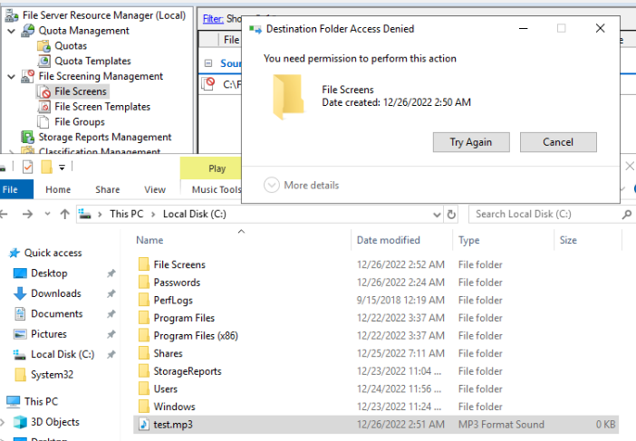

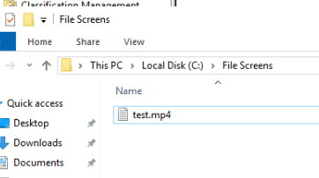

Here we configured for the folder ‘File Screen’, we would not allow any type of mp’x’ files to be placed aside from mp4 files. In the screenshot, we see that only .mp4 files can be placed in the folder.

File screening is important because it is good practice to disallow certain types of files such as executables into certain folder locations that are important. By doing so, even if a user is tricked and attempts to put malware in a sensitive location, they will not be able to do so.

**Manage Privileged Identities**

Managing privileged identities is controlling and restricting a user's and processes’ access to resources and confidential data on a computer system. As a result, certain users are given varying degrees of privilege based on the functions and duties in their scope of work.

Privilege management aims to prevent unauthorized access to and exploitation of sensitive data by ensuring that users and processes can only access resources and information to which they have been granted access.

Managing privilege identities is a critical aspect of security in computer systems, as it helps to maintain the confidentiality, integrity, and availability of resources and information, and to prevent unauthorized access and misuse of confidential information.

The next step to harden the file server is to manage privileges identities on the server. This is done by configuring user rights, delegating privileges, using task pads for easy use and lastly configuring password and account lock out policies.

**Configuring User rights:**

User rights allow a user to perform a particular action which is different from user privileges.

Group Policy Management 🡪 Domains 🡪 Default Domain Controllers Policy 🡪 Policies 🡪 Windows Settings 🡪 Security Settings 🡪 Local Policies 🡪 User Rights Assignment.

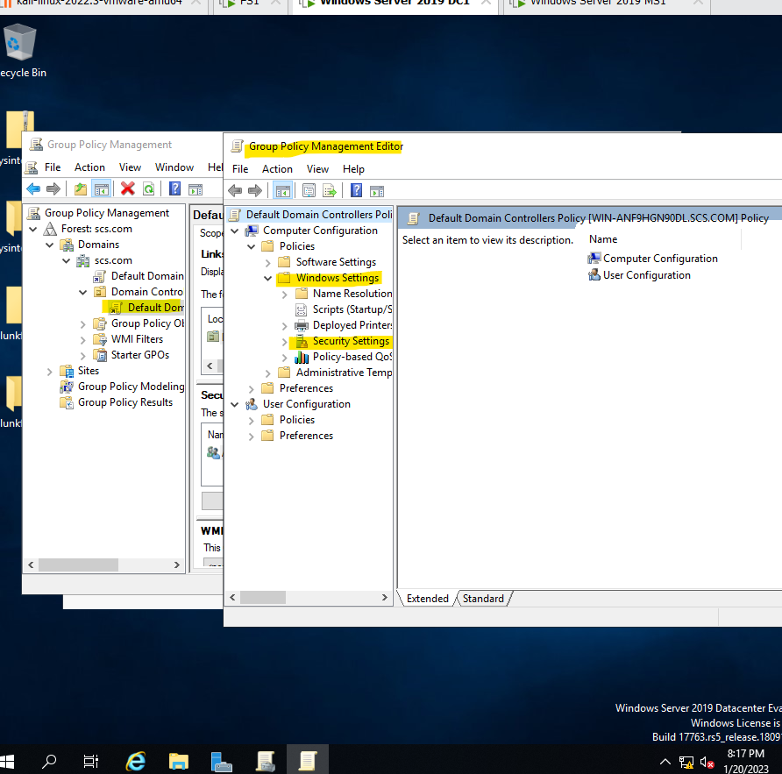

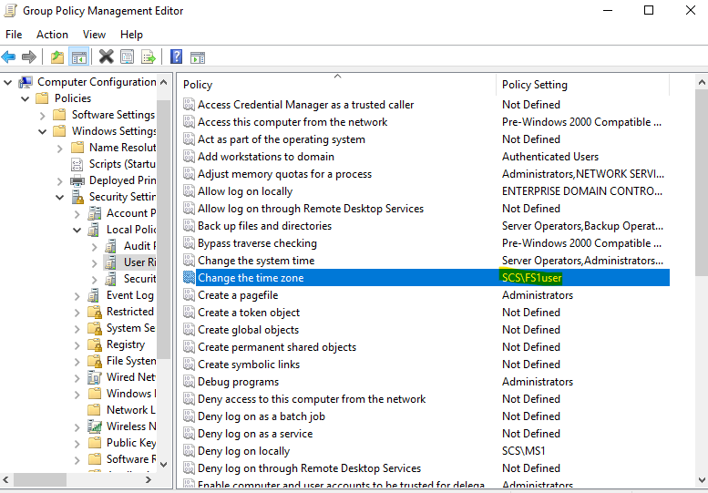

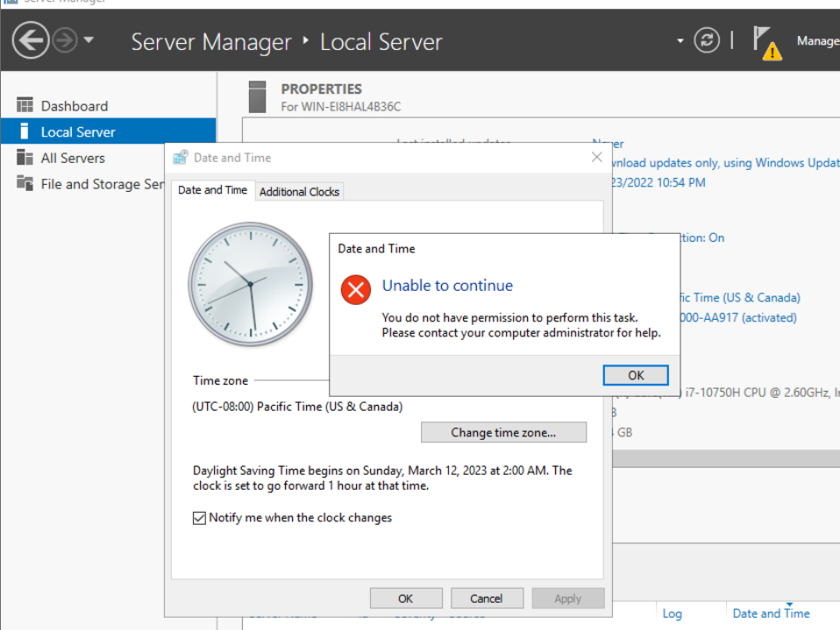

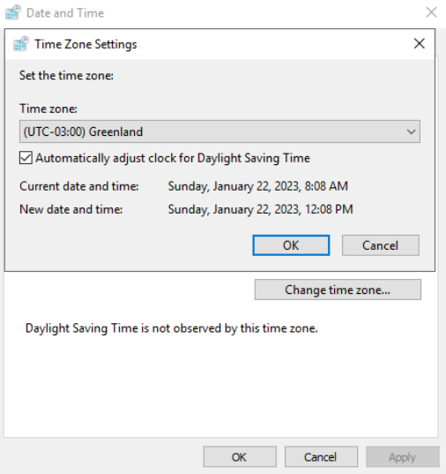

From the screenshots above, we assigned FS1 user the right to change the time zone, and normally, FS1user would not be authorized to change the time zone, but because we assigned the user the right, FS1 user is able to do so.

This is an example of how user rights could be used to ensure least privilege in a domain which would greatly improve security. This could be done at a much larger scale involving many more users, but to illustrate the point, a simple example will suffice.

**Delegate privileges:**

Typically, you delegate privileges to users when you want to give them some privileges but not make them full blown administrators. This can be done in Windows Server 2019.

Tools 🡪active directory users and computers 🡪 under scs.com click on the user’s folder 🡪 Then right click it and click delegate to go into the delegation control wizard.

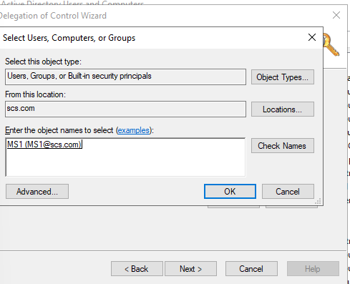

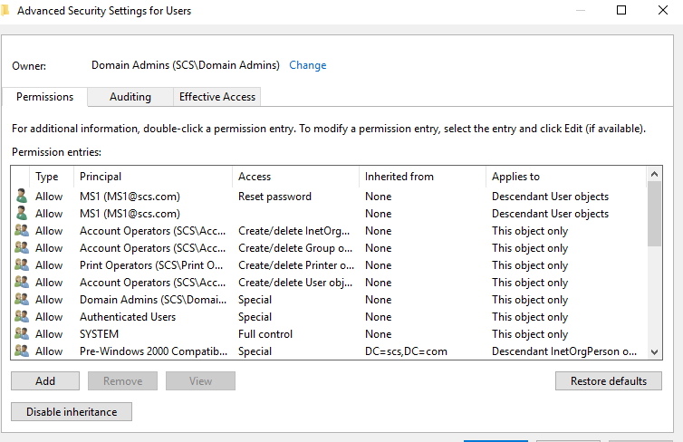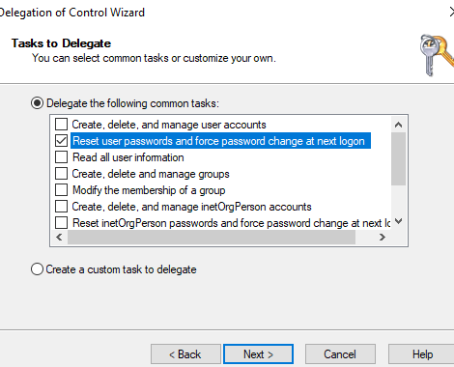

From the screenshots above, we see that the user MS1, can reset passwords of other users. This indicates that we have successfully delegated the reset password privilege to MS1 user without having to make the user an administrator.

This is helpful as often, users will require some form of administrator privileges to do their work, and this allows the server to continue maintaining least privilege amongst all users.

**Create a taskpad:**

Task pad is a tool that is used for users who have been given some privileges but are not administrators to use to easily carry out the privileges given to them.

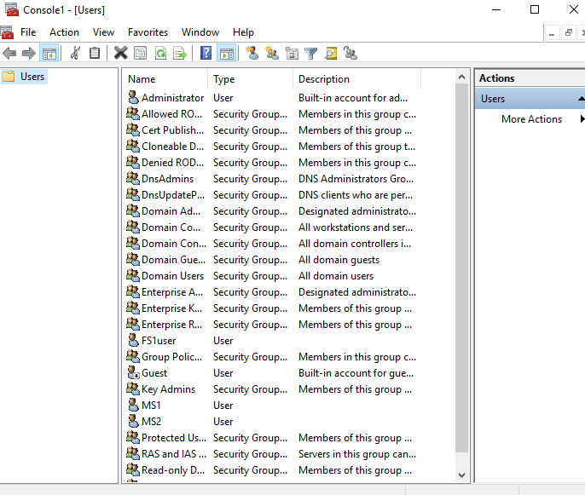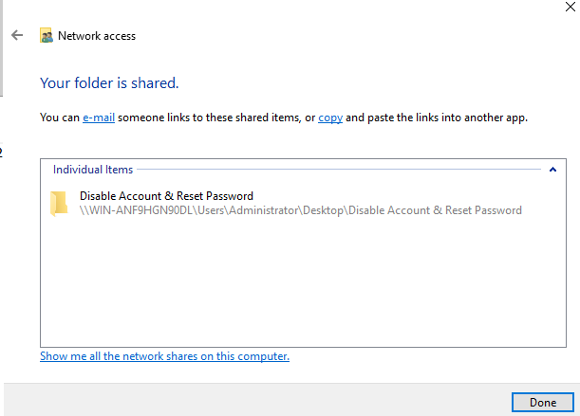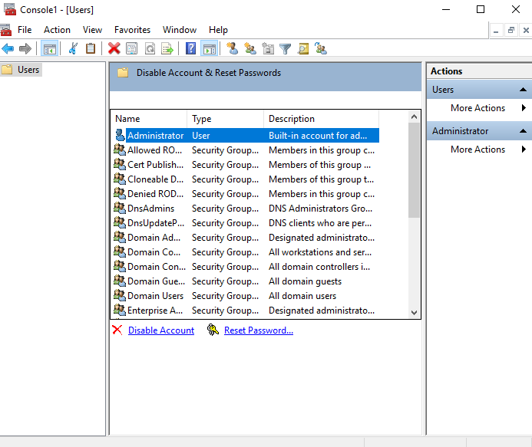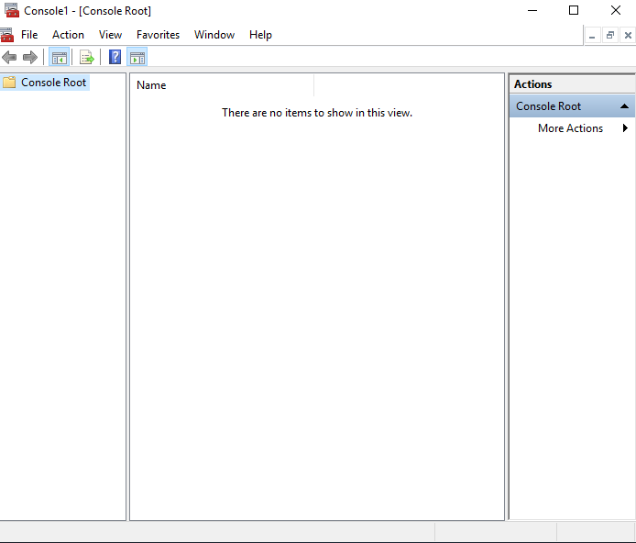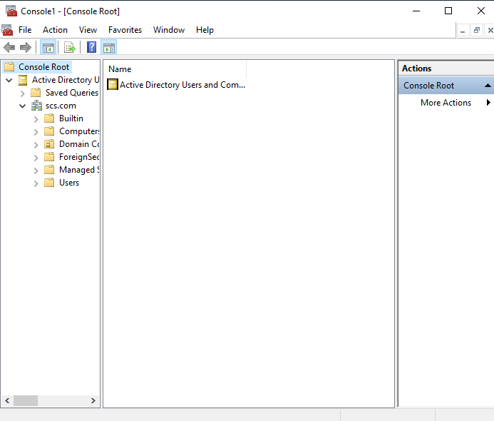

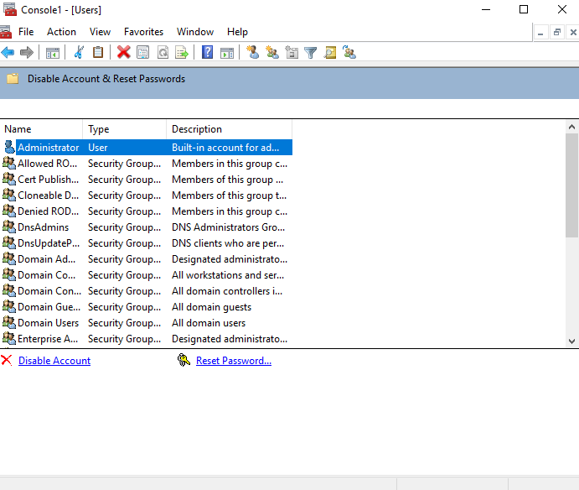

From the screenshots above, we have created a task pad that can be delegated to users. This task pad has 2 privileges, which include disabling an account and resetting the password for an account. The interface used is extremely simple which is good as that would minimize confusion and human errors.

**Password Policies**

Weak passwords are a major way in which many security breaches occurs and by enforcing password policies, we can force users to user passwords which are more secure.

To configure:

Group Policy Management Editor 🡪Policies 🡪 Windows Settings 🡪 Security settings 🡪 Account policies 🡪 Password policies.

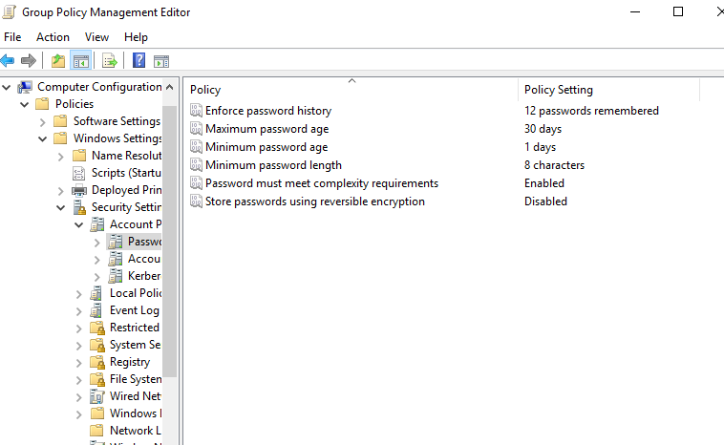

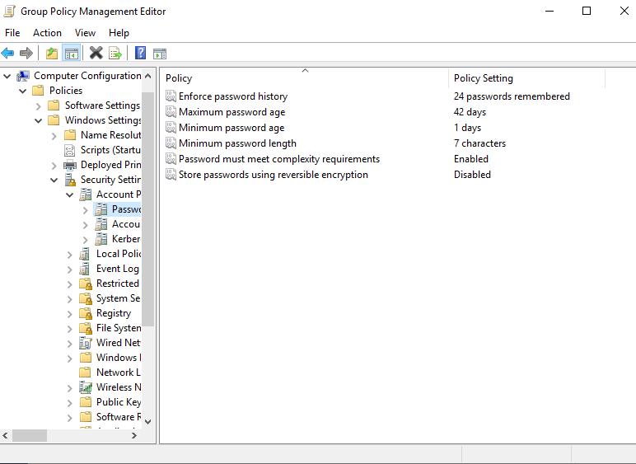

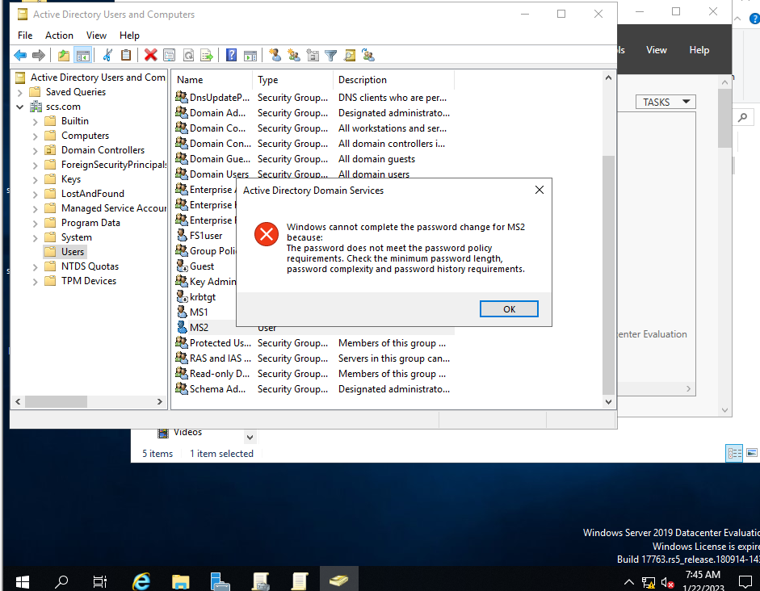

Enforce password refers to how many different passwords will be remembered before they can use the same password is again. Maximum password age refers to the longest a user can use a certain password, minimum is the period a user cannot change his password again after changing his password. Lastly, password must meet complexity requirements require the password to have some form of complexity such as including alphanumeric characters.

Here, we see that there is a password policy that has to be adhered to otherwise, the user will be unable to change his password.

Login credentials being broken is one of the largest vulnerabilities for attackers to exploit, and a strong password policy grealy prevents that from happening. It is thus vital to ensure to balance between a strong password policy and user ease of life. If the passwords are made to be too complex, users might resort to bad habits like writing the password down.

**Account lockout policy**

Similar to password policy, the account lockout policy can be configured through.

Group Policy Management Editor 🡪Policies 🡪 Windows Settings 🡪 Security settings 🡪 Account policies 🡪Account Lockout policies.

Account lockout is where an account becomes locked after a set number of failed logon attempts.

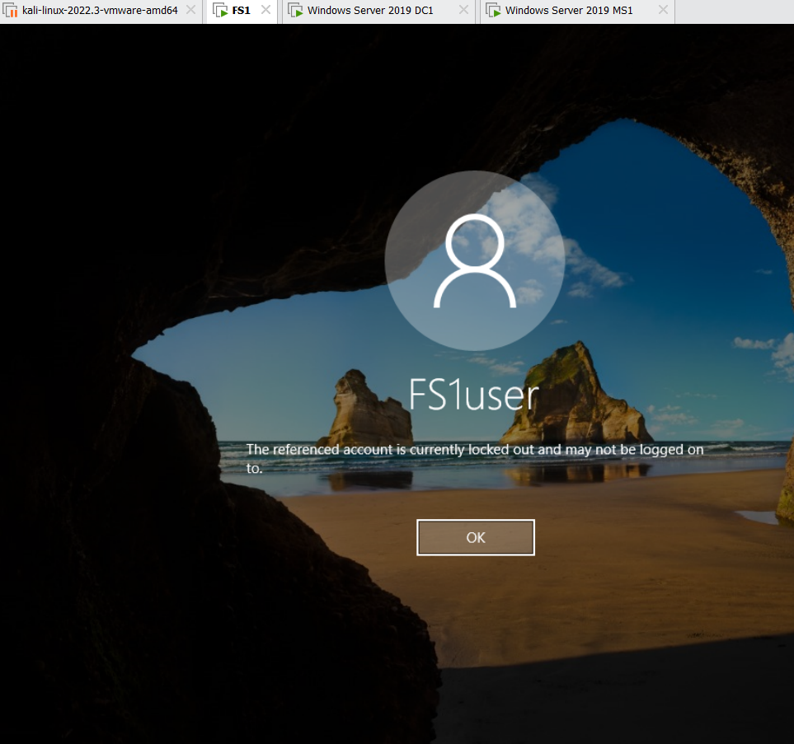

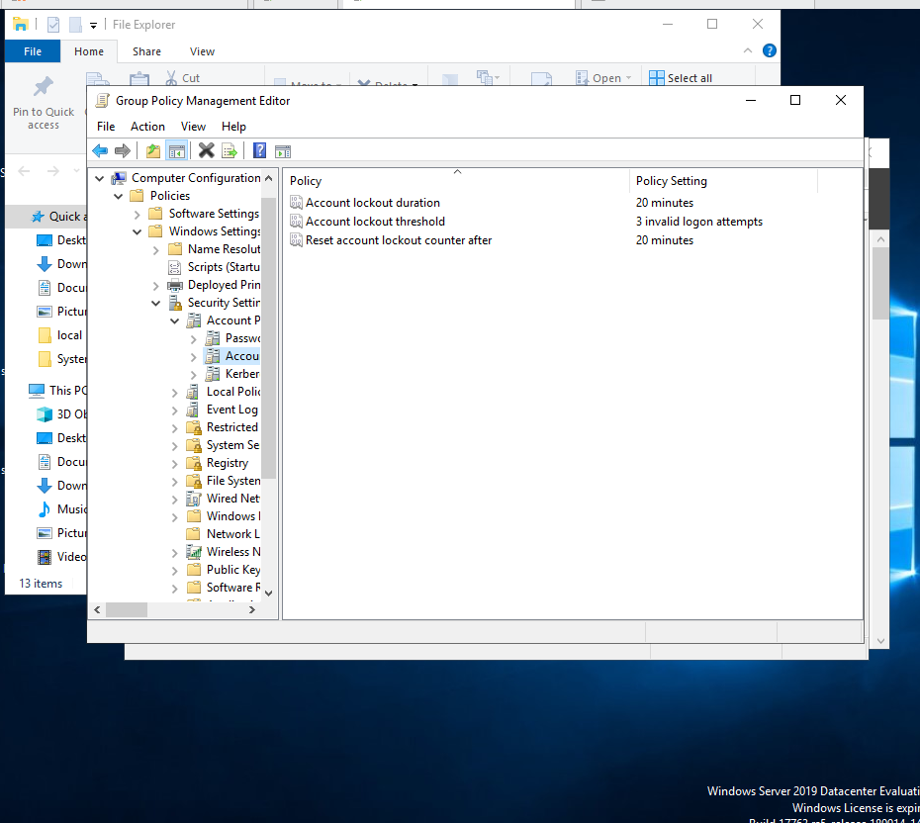

Account lockout duration refers to the time the account is locked out for should it be locked out, account lockout threshold refers to the number of times before the account is lockout out and reset account lockout counter after refers to the duration before the lockout counter goes back to 0.

From the screenshot above, we see that the FS1user account is locked out after 3 failed attempts for a duration of 20 minutes.

The whole idea of managing privileges identities is to ensure least privilege amongst all users as well as enforce rules that will hinder attacks without sacrificing quality of life for other users. An example of this is account lockout where users are given enough attempts to login even if they mistype a few times, but attackers cannot conduct brute force attacks efficiently as the account gets locked out after a set number of attempts.

**Audit Policy**

An audit policy is a set of rules and configurations used to track and monitor system activity and events on a computer. These policies are used to monitor security-related activities, such as user authentication and authorization, resource access, and changes to system configuration. The goal of audit policies is to provide a record of security-related events that can be used for troubleshooting, identifying security threats, and monitoring compliance with security standards.

Object accesses were audited to ensure accountability in the file server. Auditing allows us to know what is going on the network which helps us understand if there was malicious intent behind certain actions.

To configure audit policy:

Group Policy Management 🡪 Default Domain Policy 🡪 Right Click Edit 🡪 Policies 🡪 Windows Settings 🡪 Security Settings 🡪 Local Policies 🡪Audit policy.

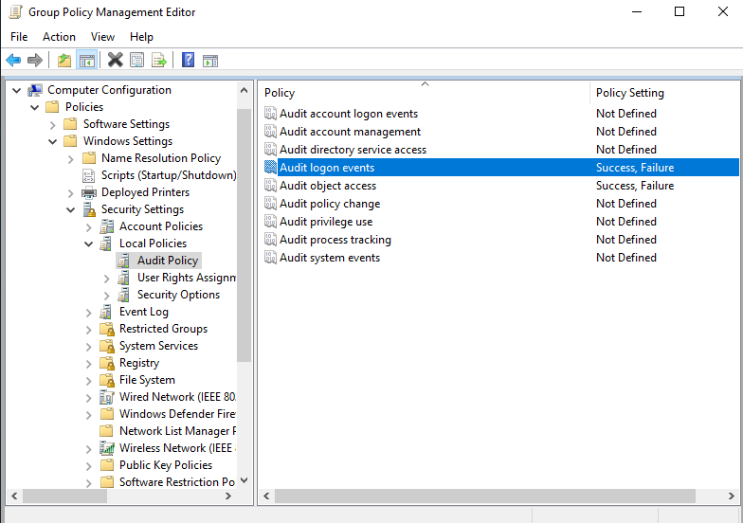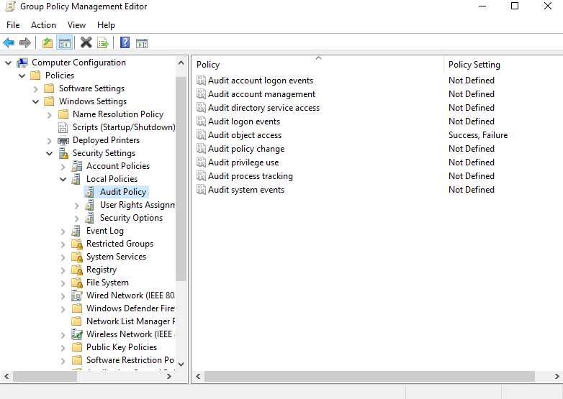

From the screenshots above, we have audited logon events and object access. It is good practice to audit both success and failure which would let us know when someone is failing too many times indicating a malicious intent.

**Audit Object access**

Auditing object access requires an extra step to audit. This is because if every object in the server is audited, there would be too many log entries. Thus, we must select the files and folders that we want to audit object access for.

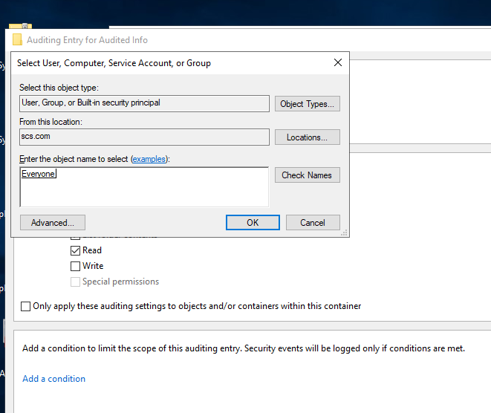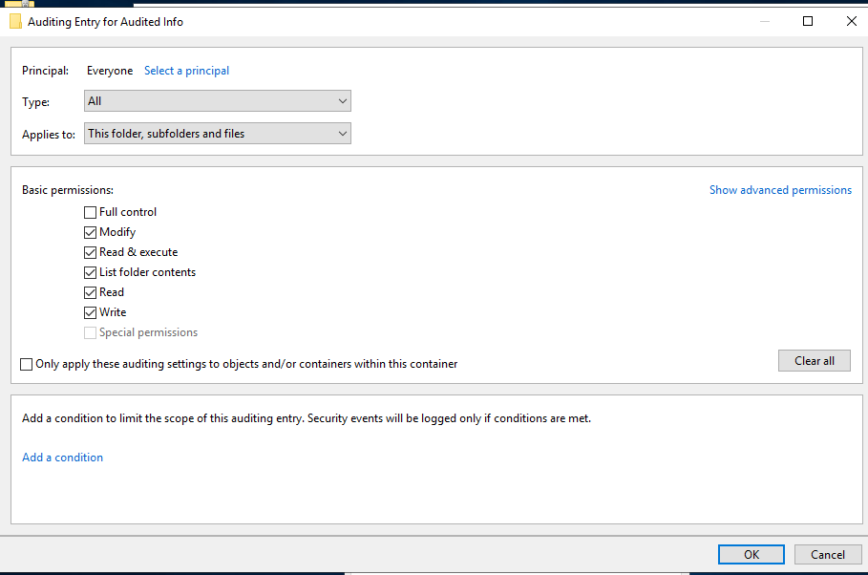For demonstration, I created a folder called Auditing Info to enable auditing for.

From the screenshots above, we are going to enable auditing for everyone who accesses this folder. It is good practice to audit group or everyone and bad practice to audit individual users. Reason being that auditing an individual often leaves you blinded from other user’s actions.

We can also see the different permissions we can control as well as whether the auditing is done for the folder, subfolder and files. You can also control whether to audit the success of failure or both.

**Advanced audit policies**

Advanced auditing policies allows us to audit actions on the server at a more granular level.

To configure:

Group Policy Management Editor 🡪 Default Domain Policy 🡪 Right click and edit 🡪 Windows Settings 🡪 Security Settings 🡪 Advanced Audit Policy Configuration 🡪 Audit Policies.

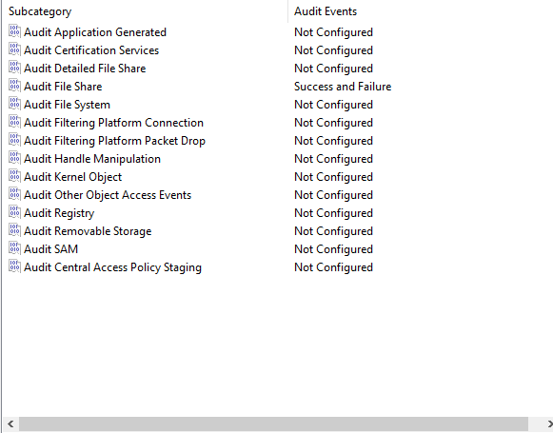

# 

These audit policies are like the regular audit policies. You can audit both their successes and failure and they also have an explain tab which explains the policy.

Here, we configured audit file share where the audit event is generated when an attempt is made to access a shared folder.

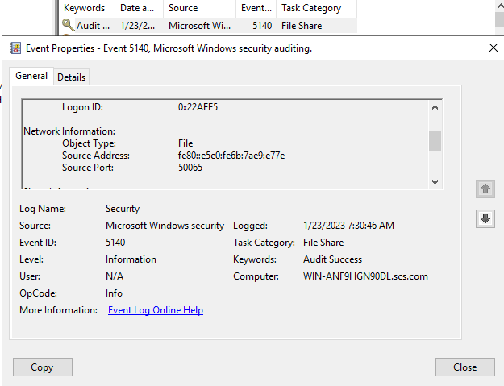

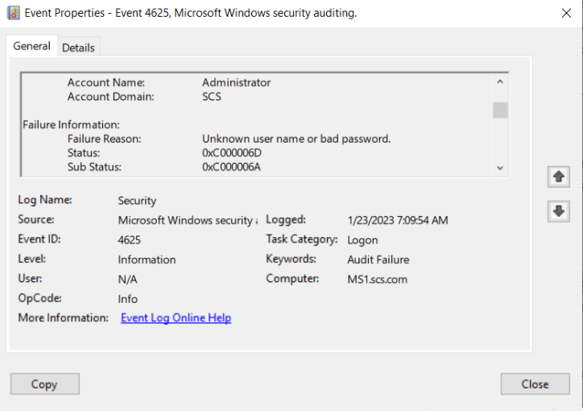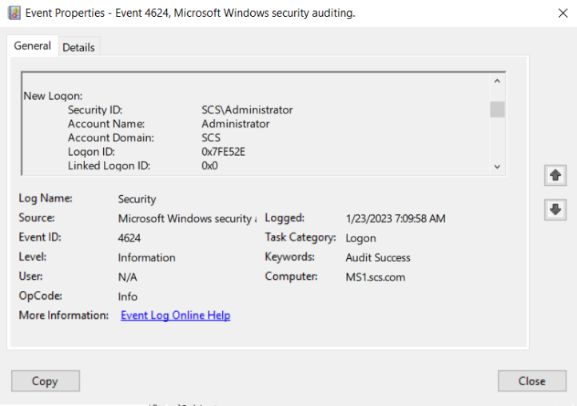Here we see that the file share policy is audited indicating that the advanced auditing policy works.

Also, user’s logon successes and failure are audited.

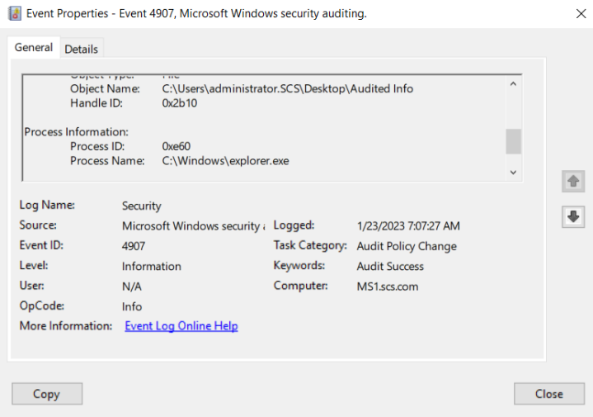

We see that there are auditlogs for the various activities that we audited. Indicating that it is configured correctly. This was user log on success and failure and file share policy.

Lastly, auditing for object access works as well. Here we see the importance of auditing as we can see the various actions performed which can give us great insight as to whether there is any malicious intent or attacks targeted at the server. This allows us to stop the attacks or if the attack was to already take place, then the logs would allow us to gather useful information as to how the attack took place.

# 3. Explain the key functions / features of the proposed security tool(s)

**Anti-Malware (Windows Defender)**

Windows defender is a built-in antivirus software in the Windows operating system. It is aimed at protecting the operating system against malware, viruses, and all types of malicious software. Below are some of its features:

1. Real-Time protection: Offers Real-time malware and other security threat prevention, which keeps a watch on the computer for any suspicious activity and promptly blocks any malicious software that it detects.
2. Signature Detection: To identify and prevent known threats, Windows Defender employs a database of commonly used malware signatures. To remain relevant with the most recent security threats, Windows Update frequently updates this database.
3. Behaviour monitoring: Also, it can detect potential malware, Windows Defender also keeps a close watch on how the device's processes and applications behave. It will disable the software and notify the user if it detects any suspicious behaviour.
4. Network protection: Also provides network security by maintaining a watch on your network for any suspicious behaviour and alerting you of possible security risks.
5. Scheduled scans: To detect potential malware, Windows Defender also keeps a close watch on how the device's processes and applications behave. It will disable the software and alert the user if it detects any suspicious behaviour.
6. User-friendly: It also provides a user-friendly user interface that makes it simple for users to understand and use the program.

**Backup (Windows Backup)**

A built-in feature in Windows to create a backup of important data and files as well as system settings to protect against data loss.

1. File and folder backup: Allows users to backup specific files and directories, including system state information, which is vital for restoring a server to a previous state.
2. Volume backup: Able to create whole volume backups, including system and boot volumes, making it easy to restore an entire server in the event of a disaster.
3. Incremental backup: Allows for incremental backups, which back up only the changes that have been made to a volume since the last full backup. This allows for smaller backup file size and faster backup times.
4. Backup scheduling: gives you the ability to schedule backups to run automatically at a fixed time, ensuring that your data is regularly backed up.
5. Backup to external storage: Allows backups to network shares or tape drives as external storage options. This allows users to store backup data offsite for further prevention of information loss.
6. Backup management: Includes a management console that enables management of backups, viewing of backup reports, and data recovery from a backup.
7. Restore options: Provides a variety of data recovery options, including the ability to restore a volume or computer to a prior state.

**Full Disk Encryption (Bitlocker)**

Bitlocker is a full-disk encryption feature available in certain Windows versions that provides protection by encrypting the entire disk.

1. Strong encryption: Encrypts the data contained on a disk using 128-bit or 256-bit Advanced Encryption Standard (AES) encryption.
2. Resistant against offline attacks: resistant to cyberattacks where the hacker tries to gain access to data without starting the operating system, such as offline attacks.
3. Encryption key management: Supports a variety of encryption key management methods, including the use of a password, USB key, or a Trusted Platform Module (TPM).
4. OS and recovery key protection: Defends against attacks that attempt to retrieve the encryption keys by encrypting the os and recovery keys.
5. Automatic encryption: Can be configured to start the system with the disk encrypted.
6. Compatible with other security features: Can be used in conjunction with security tools like firewalls to provide comprehensive security for the system.
7. Integrated with Microsoft AD: Administrators can manage the encryption keys and restrict access to encrypted data because Bitlocker is integrated with Microsoft Active Directory

**Vulnerability Scanning (Microsoft Safety Scanner)**

Microsoft Safety Scanner is a free, portable antivirus tool that provides on-demand scanning to help detect and remove malicious software including viruses, spyware on a computer.

1. Scan 24/7: Can be ran at any time to scan the machine for malware such as viruses and spyware.
2. Portable: Is a practical choice for scanning and removing harmful software from affected systems because it does not need installation and can be launched from a USB drive or CD.
3. Automatic updates: Secured against the most recent security risks because it is updated frequently to detect the latest dangers.
4. Compatible: Works well with many different versions of Windows such as Windows 7, 8, 8.1 and 10.
5. Detailed results: Gives thorough details on any threats it finds, including the type of threat and the location of it on the computer.
6. User-friendly: Easy and simple to use interface, even non-technical users can easily learn to use it.

# 4. Installation and configuration of the tool(s)

Below are the screenshots and steps to follow to configure the 4 tools mentioned in Windows Server 2019.

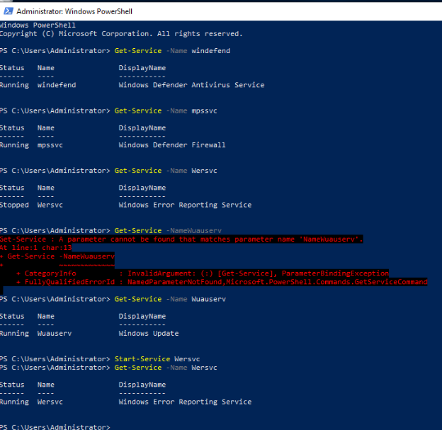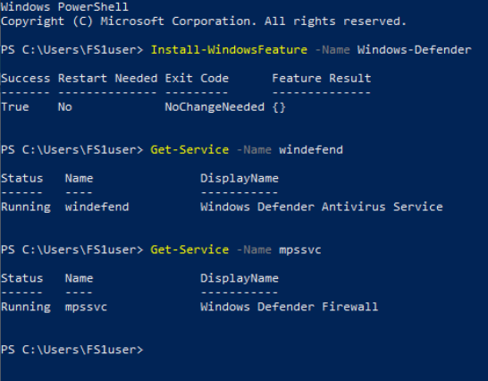**Anti-malware**

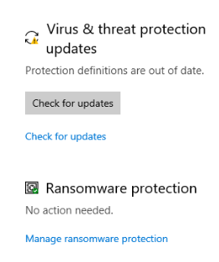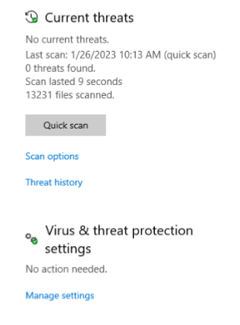

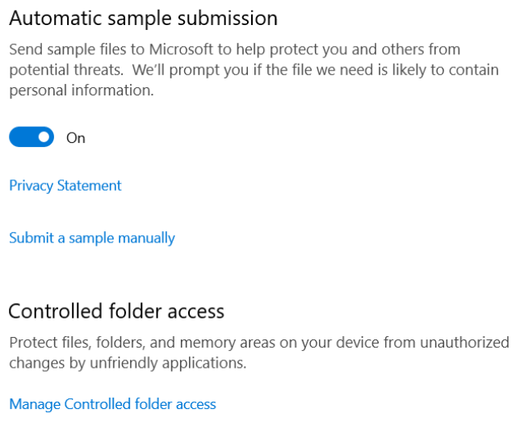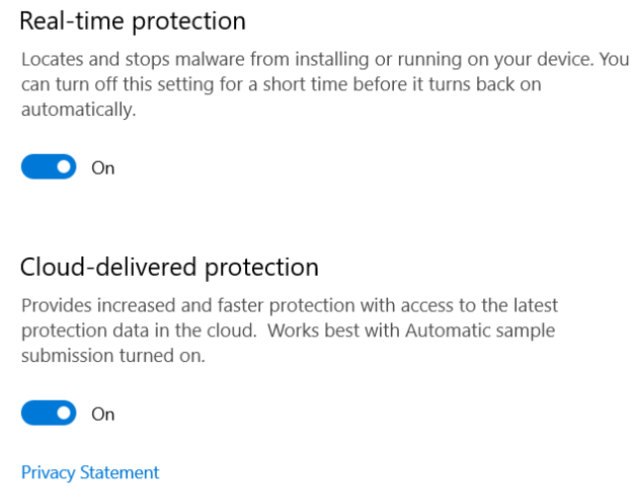

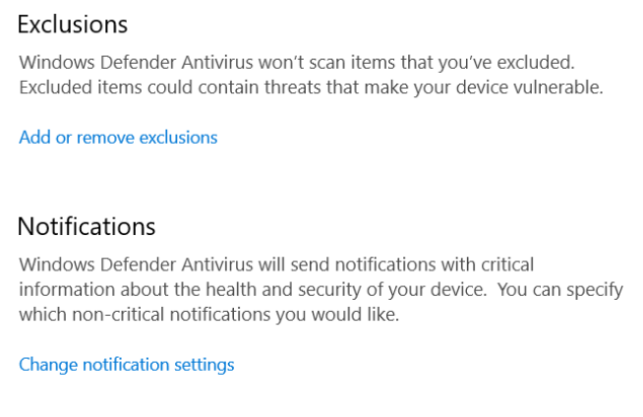

Above, we can see the different options that Windows Defender has available. It has settings like enabling automatic sample submission, cloud-delivered protection, exclusions, notifications, and many more which all aim at better detecting malware and protecting the host system.

**Backup**

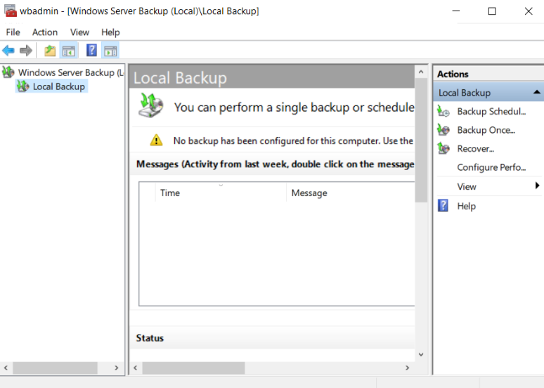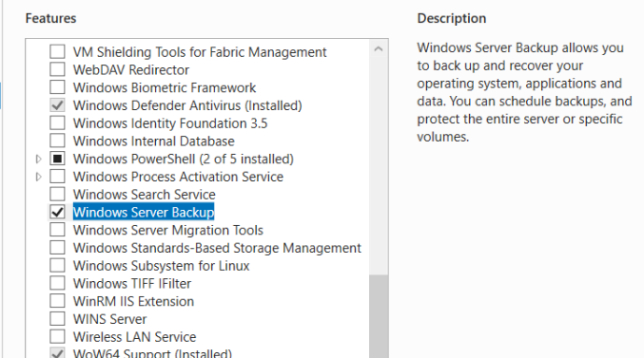

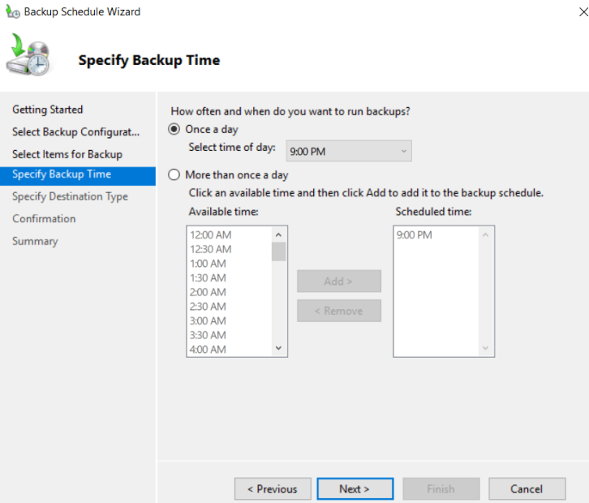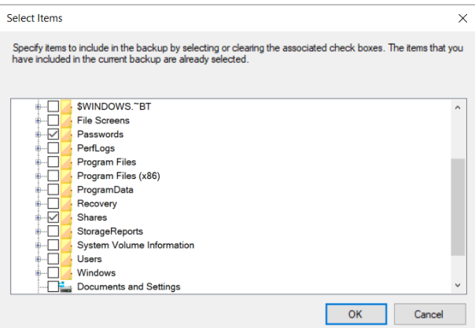

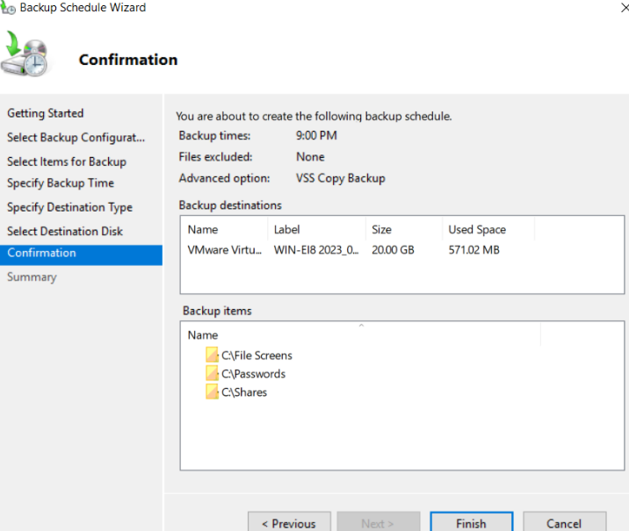

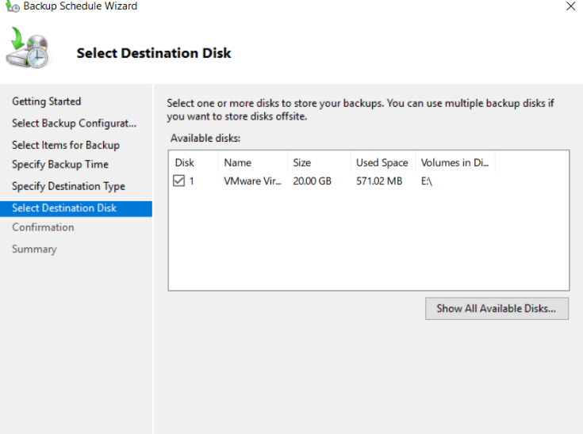

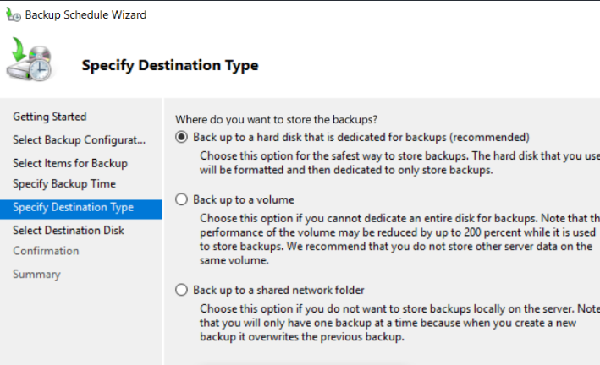

From the backup configurations, we see the different features that were listed previously such as the ability to back up a volume or to a shared folder. We can also choose the folders to backup, the time of backup, the destination where we want to backup the data to.

We also have the option of performing just a single backup.

**Microsoft Safety Scanner**

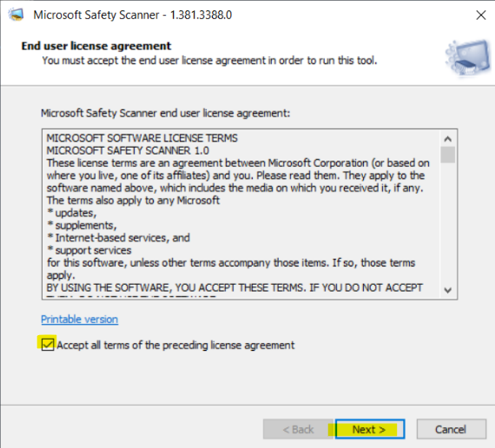

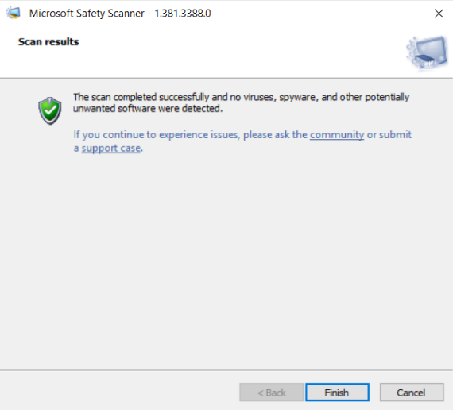

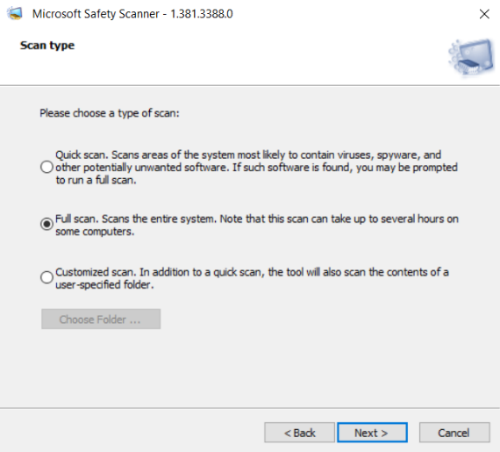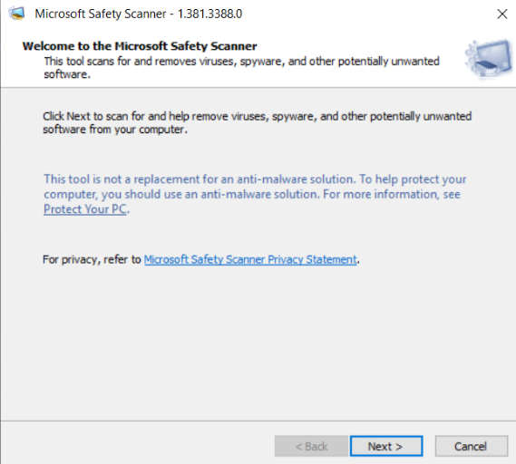

To run the scanner, we just must launch the executable downloaded. The link to download the executable is <https://go.microsoft.com/fwlink/?LinkId=212732>.

We can choose to perform a quick scan, full scan or customized scan.

**Bitlocker**

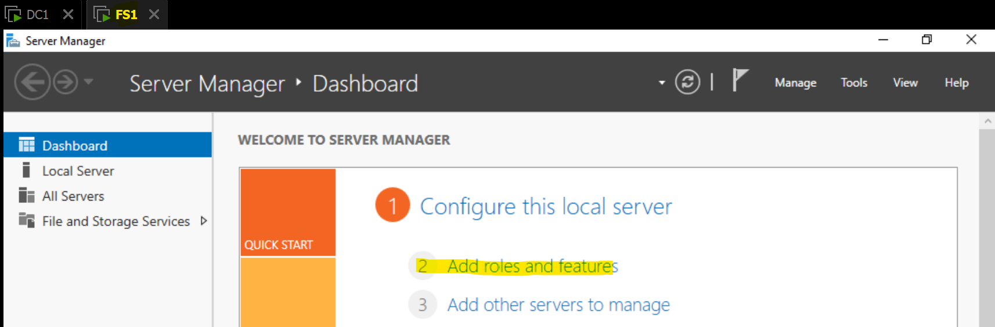

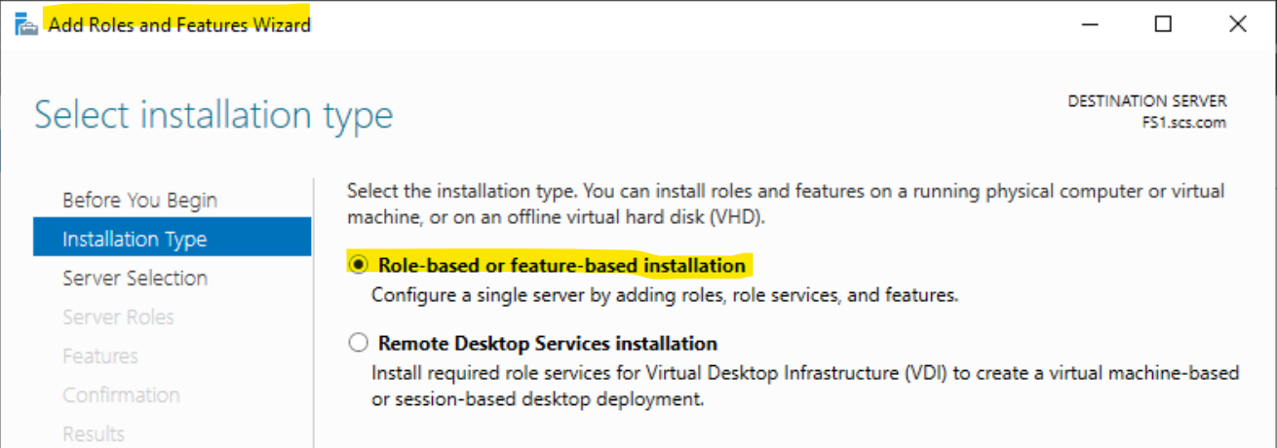

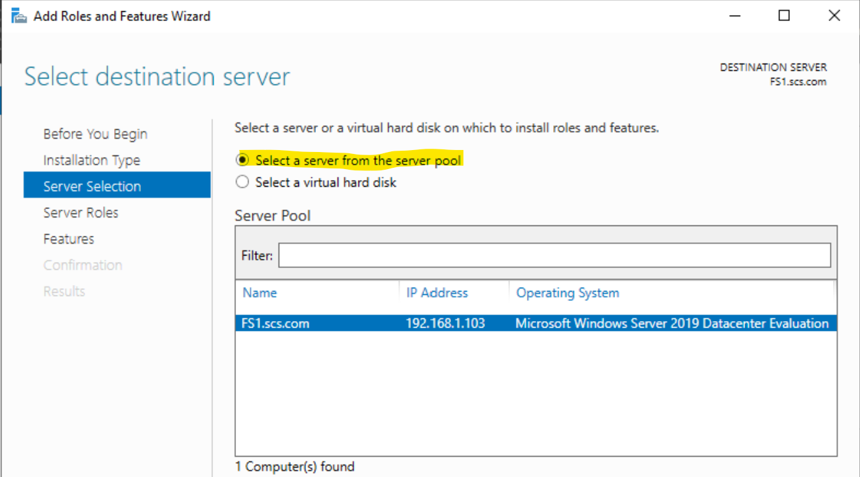

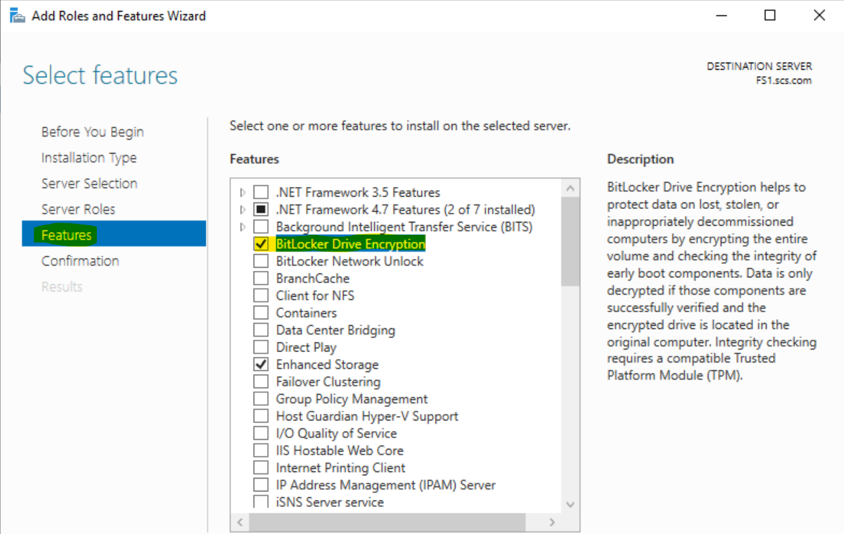

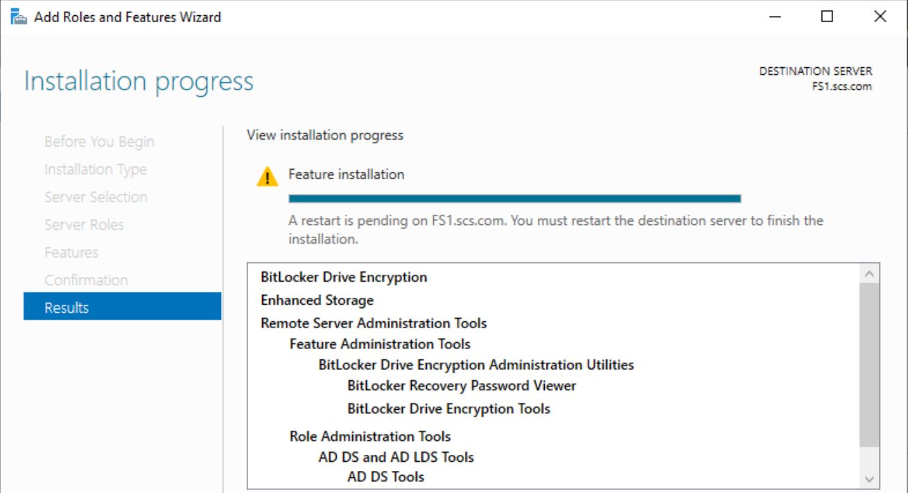

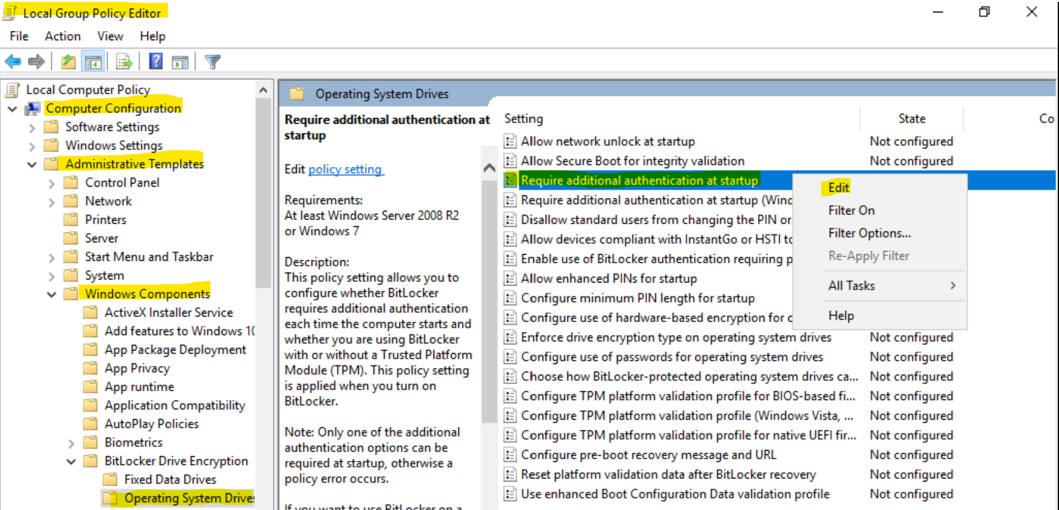

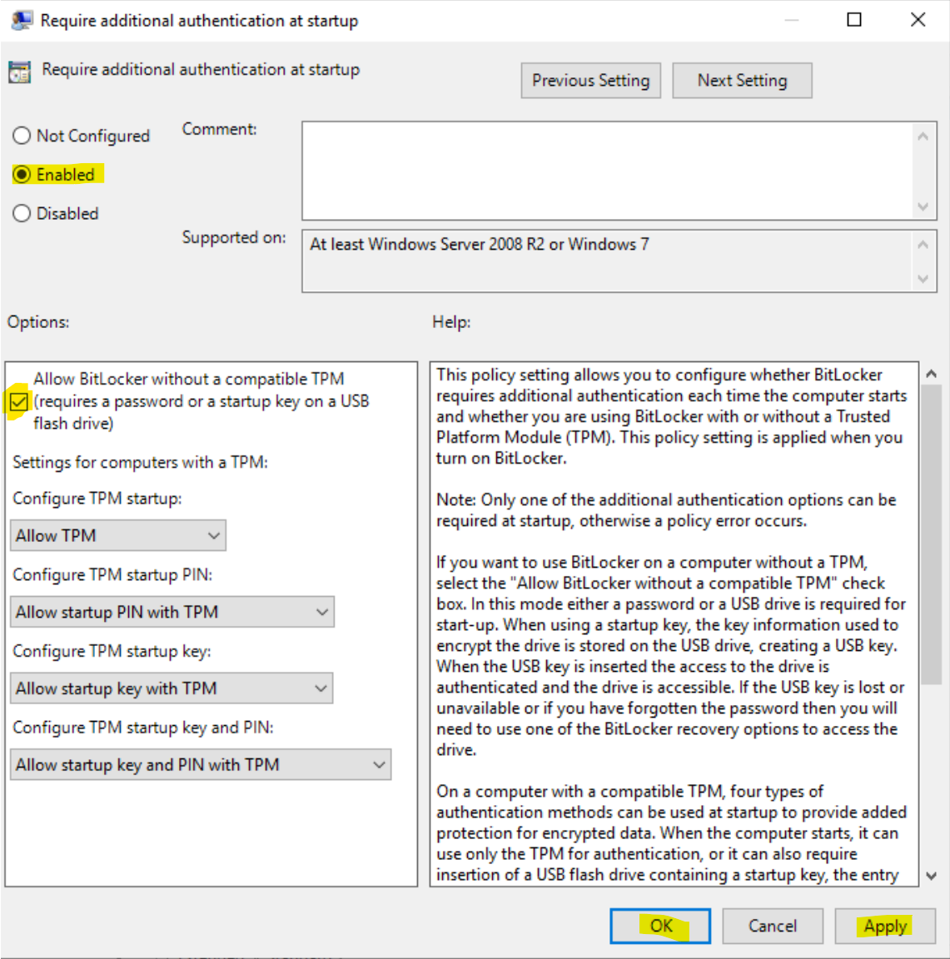

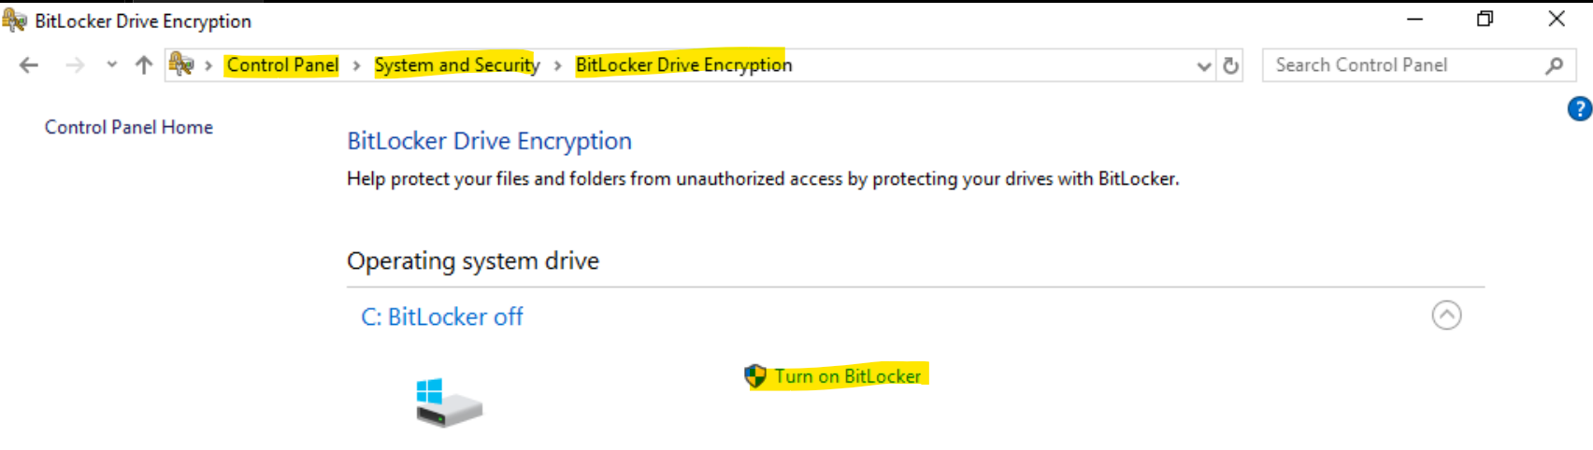

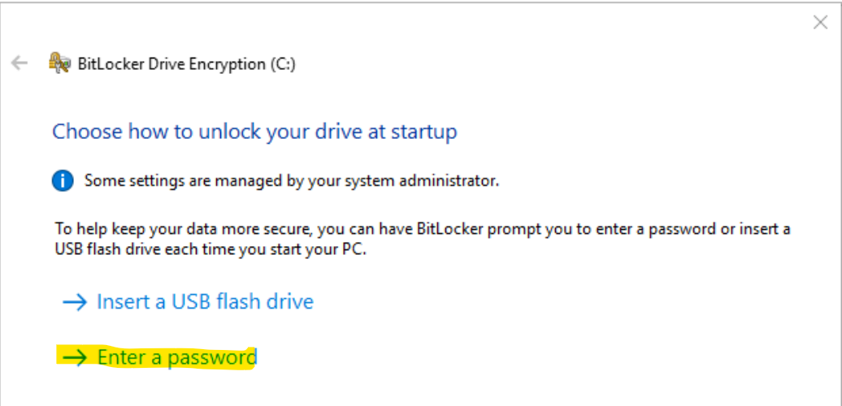

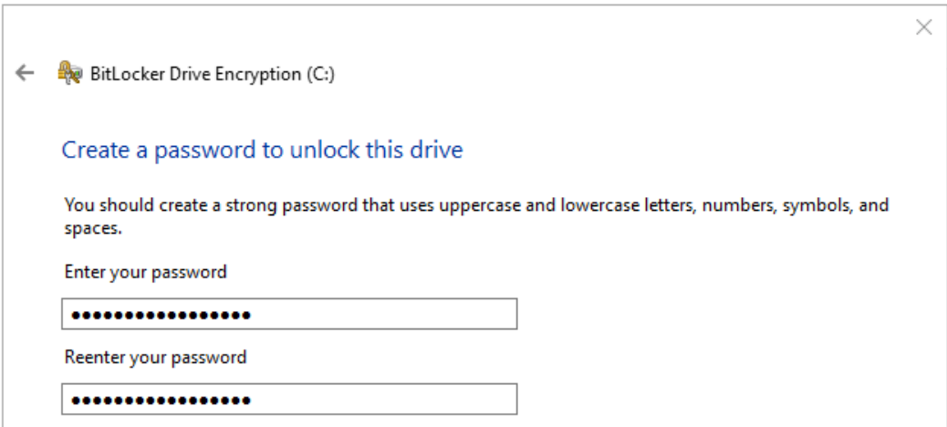

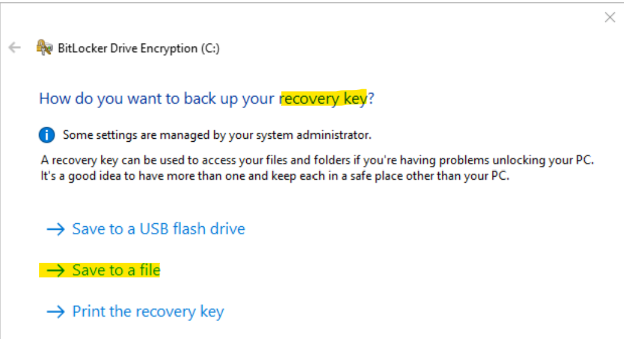

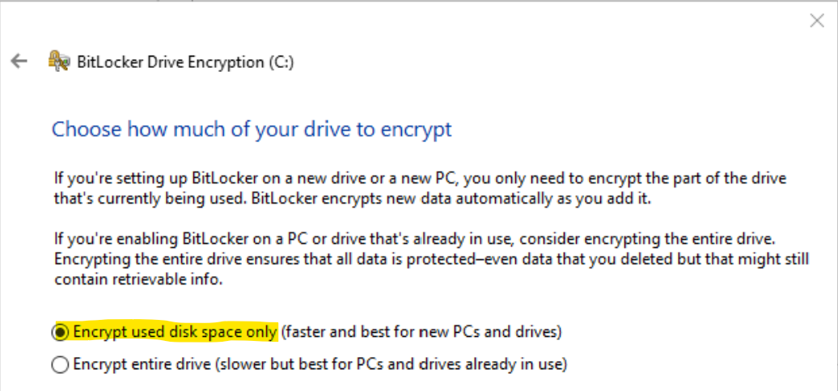

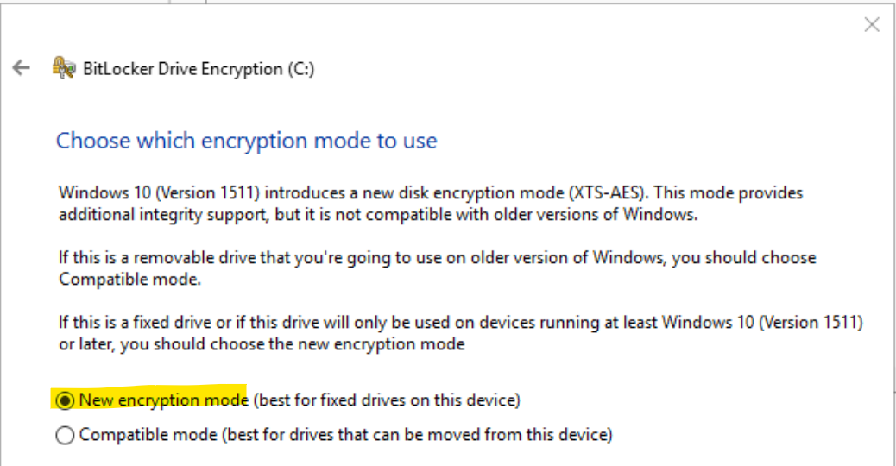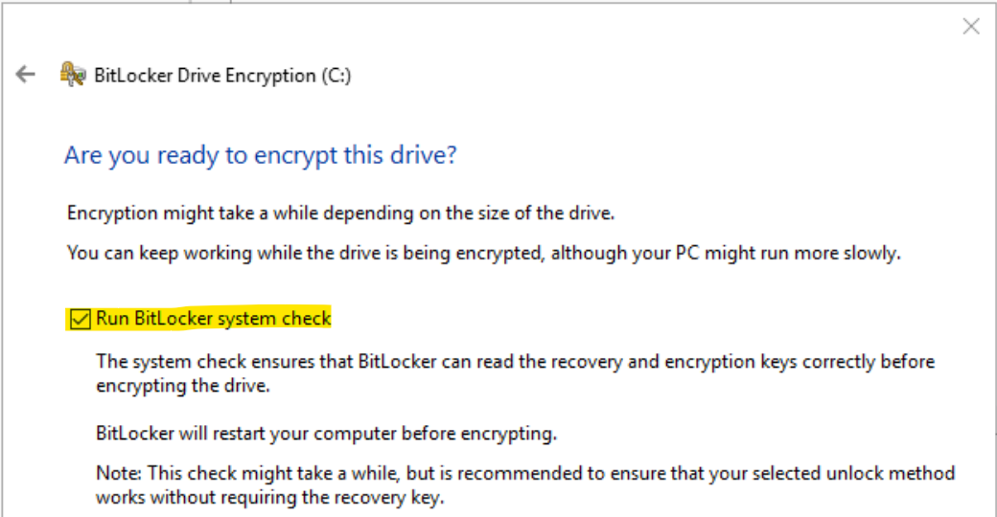

Here we see that we had to configure some settings in order for Bitlocker to be enabled and usable, after doing so, we are able to choose which drives to enable Bitlocker for. By doing so, those drives will be encrypted by Bitlocker.

This indicates that Bitlocker has been configured and installed on the server.

## 4.1 Test cases and perform testing & evaluation of the tools.

**Anti-Malware**

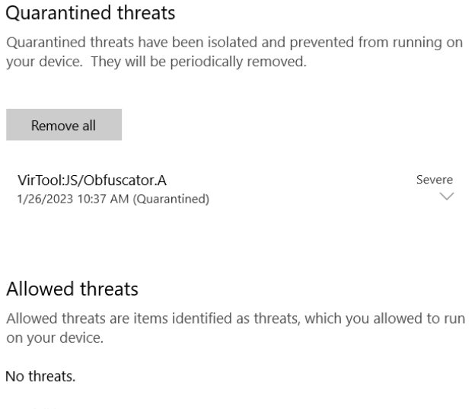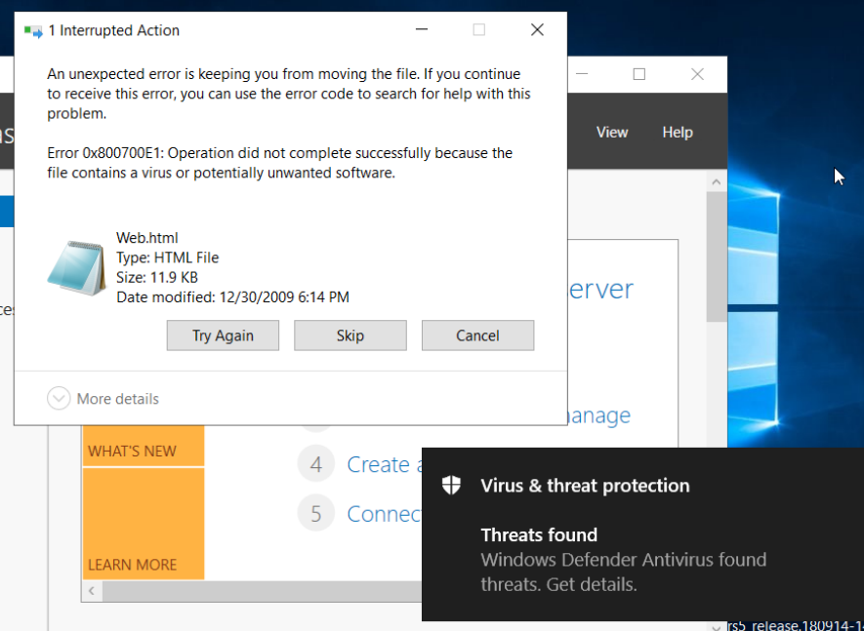

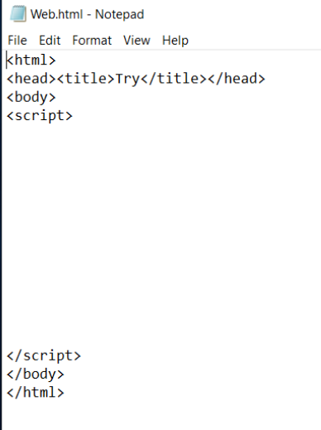

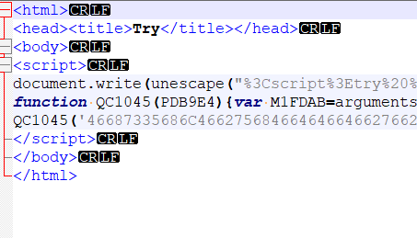

To test Windows Defender, we uploaded a malicious html file called Web.html. Windows Defender was able to detect this and remove the code in the file, rendering the malicious file useless.

The screenshot on the left shows the code in the file before Windows Defender removed it. This clearly shows that Windows Defender is able to detect malware and remove malware from the system.

This shows that the tool has been configured appropriately and is working as intended to protect the system. This is an effective tool at detecting and removing malware.

**Backup**

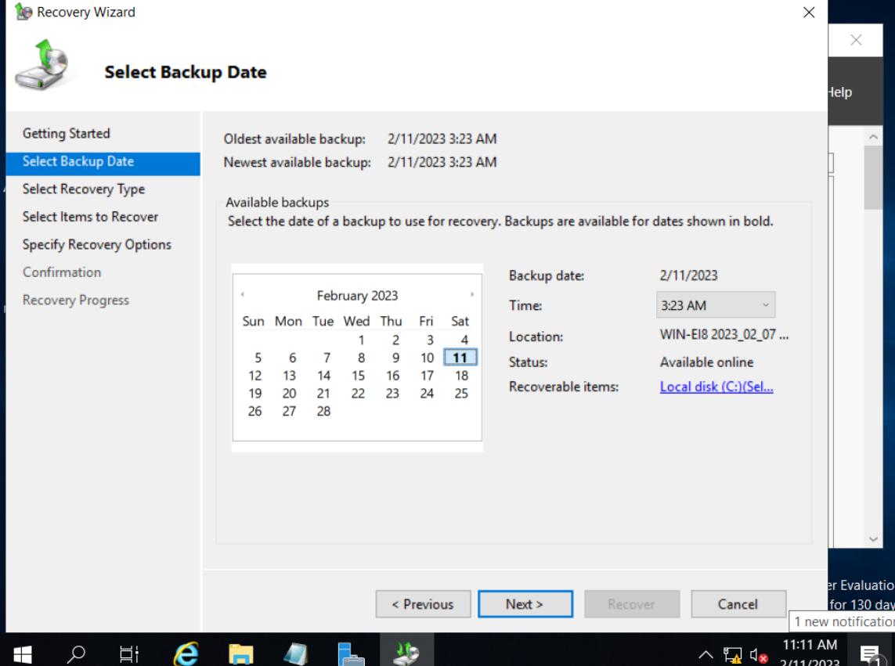

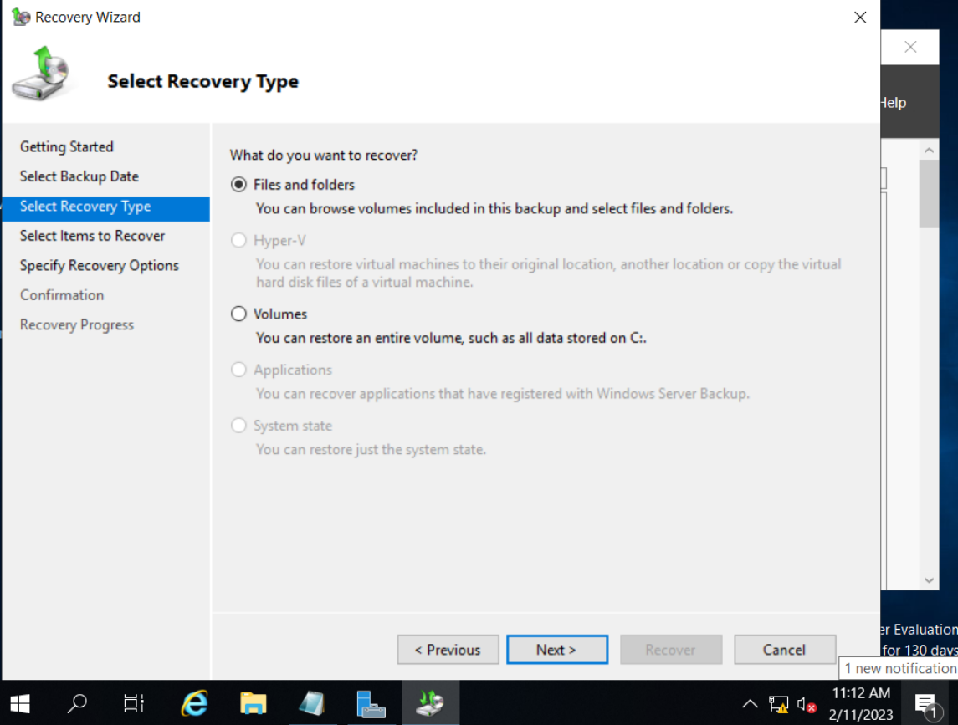

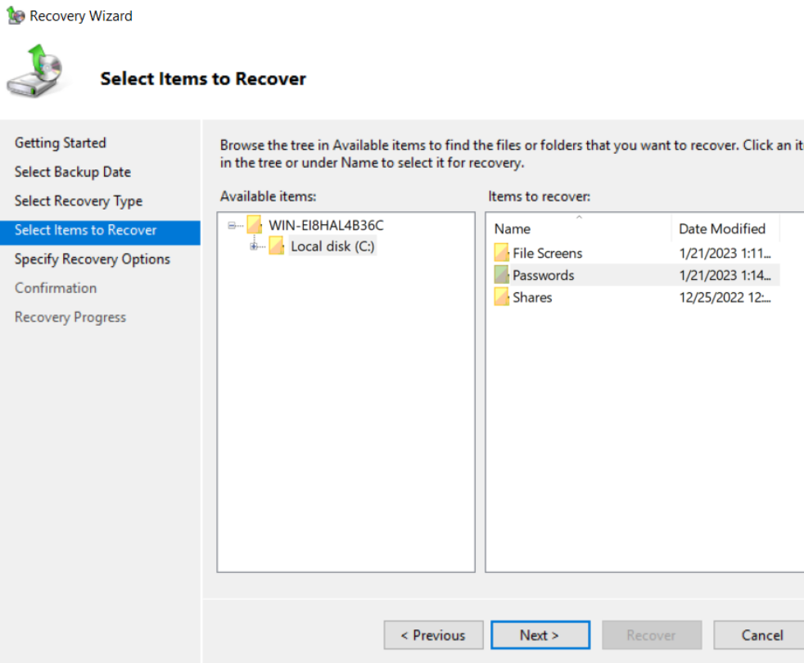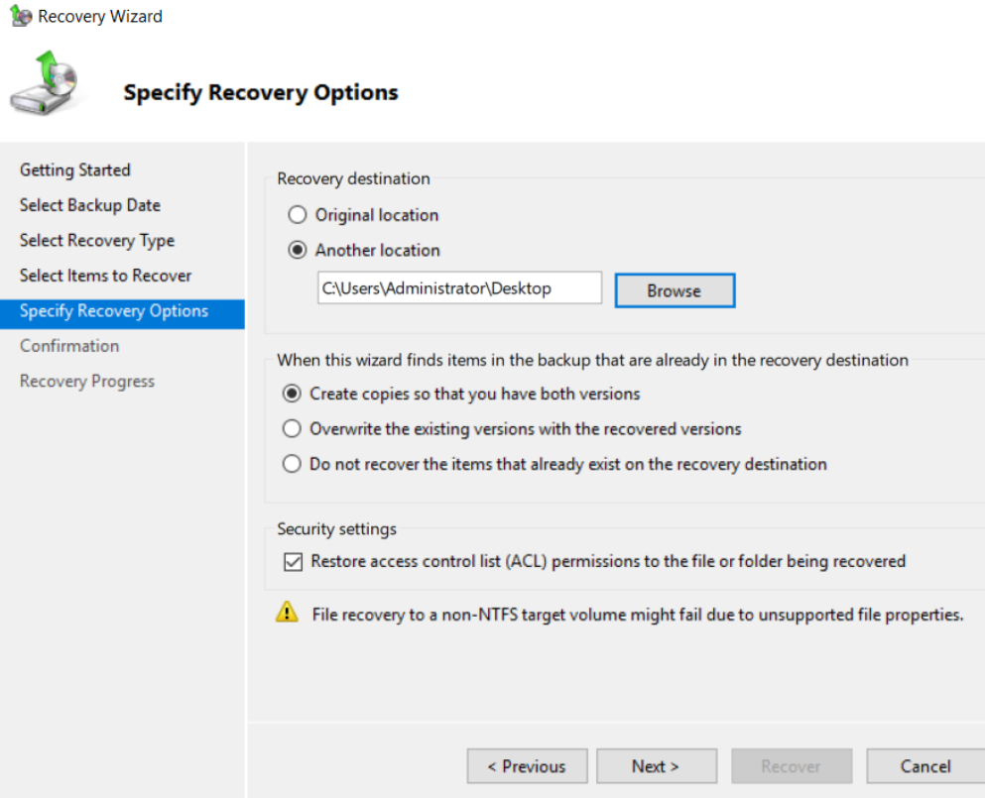

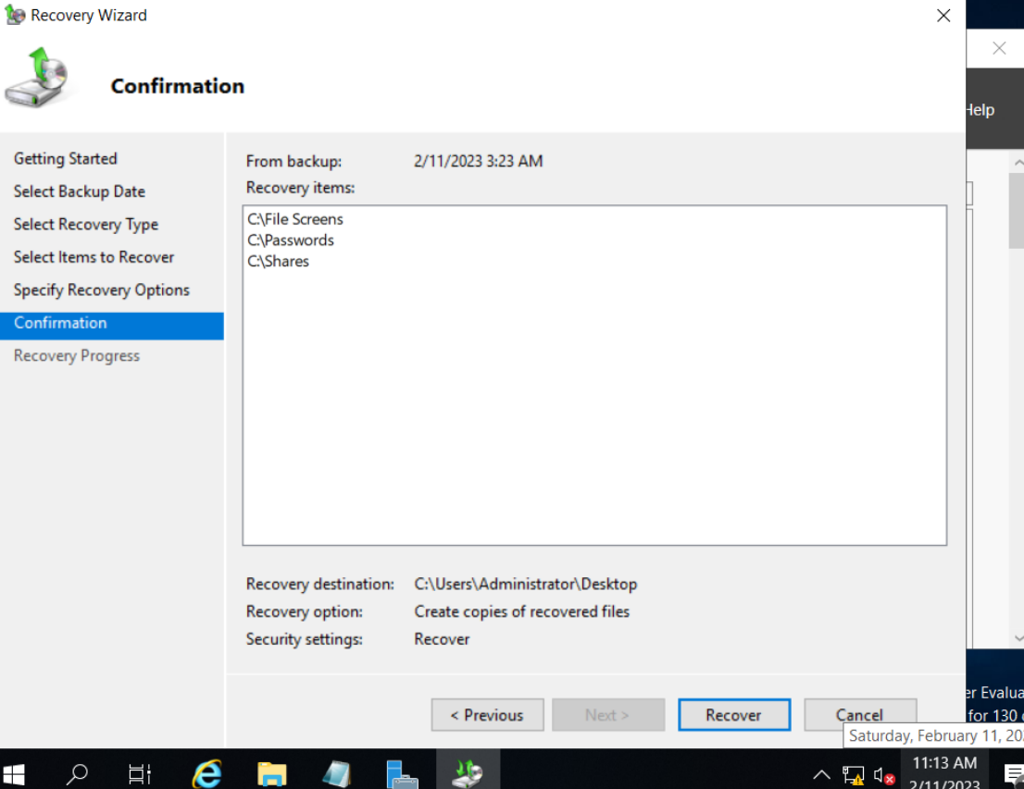

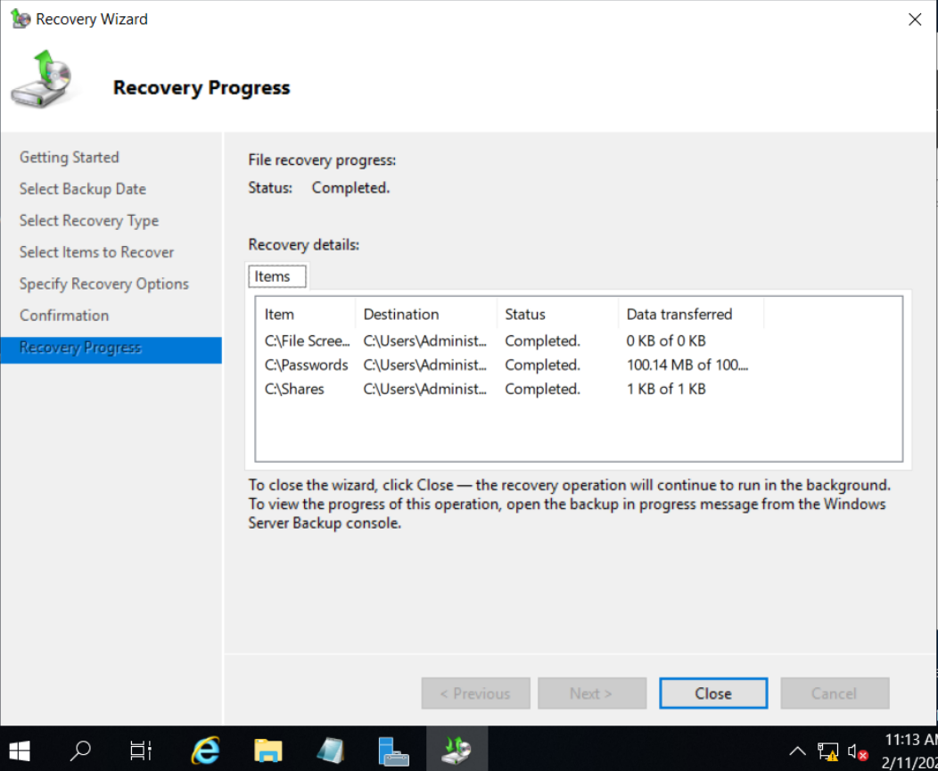

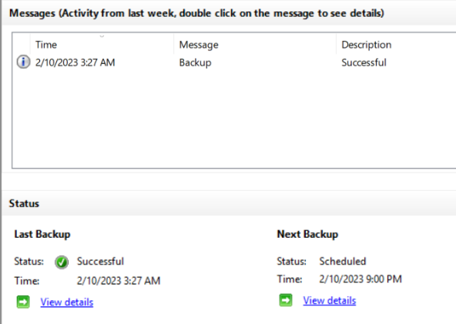

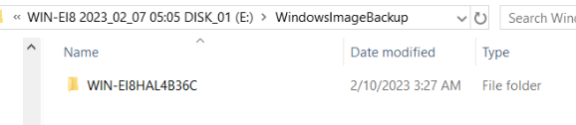

Here we see that the backup is working and that the content backed up is placed in the right destination.

We also see that we can recover the backup data anytime we want, and this operation is fully functional.

Through this the configuration of the backup is successful and it is working as intended. This backup tool is effective and dependable as a backup software for the file server.

**Bitlocker**

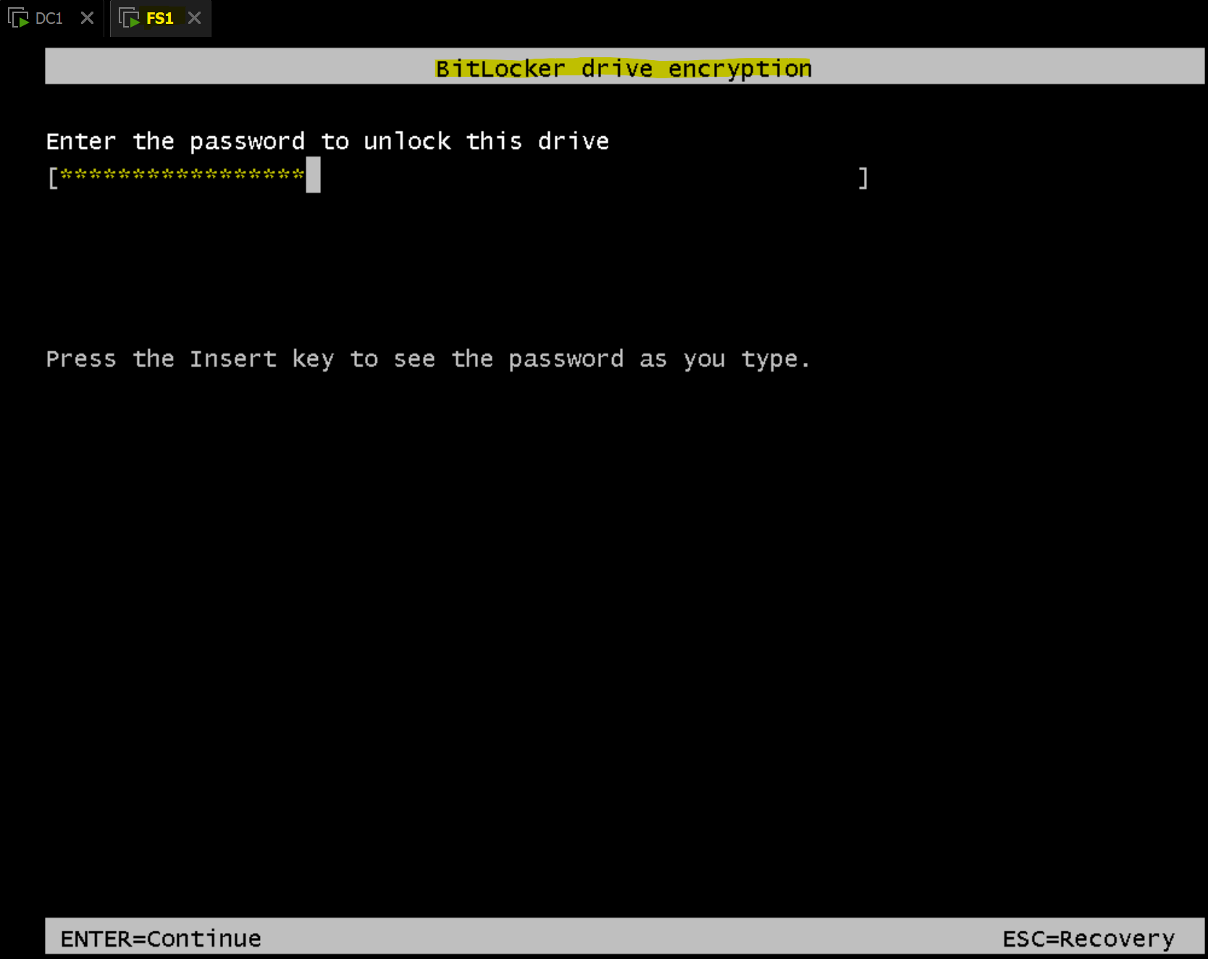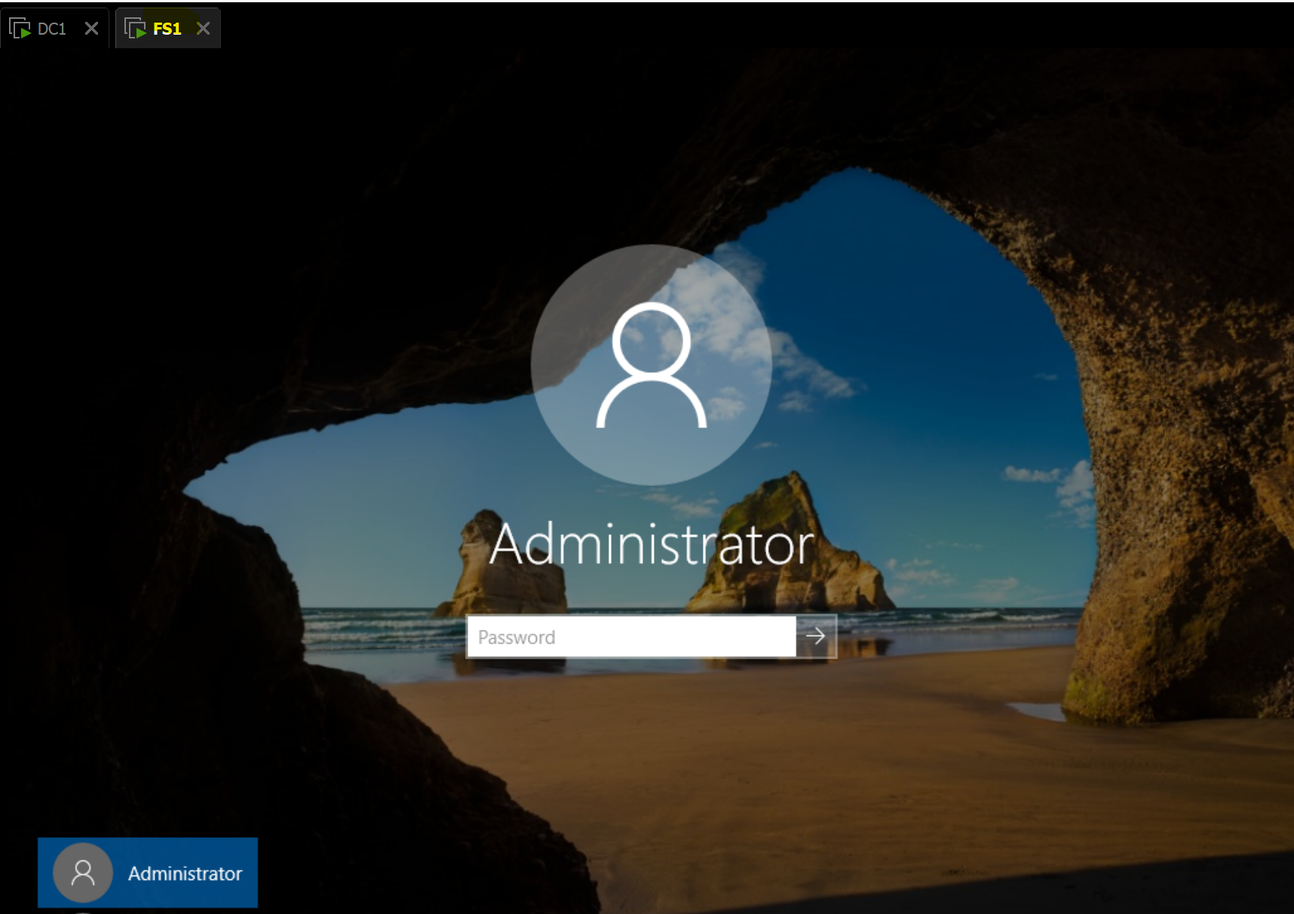

On system start, we are required to enter the Bitlocker password and only then are we able to authenticate into an account. This means that attackers would not be able to authenticate into any account even if they had access to the computer if they did not know the Bitlocker password.

The configuration is successful and the tool, Bitlocker, is working as intended providing an extra layer of security. This makes Bitlocker an effective tool at protecting user’s data and ensuring confidentiality of the data.

**Microsoft Security Scanner**

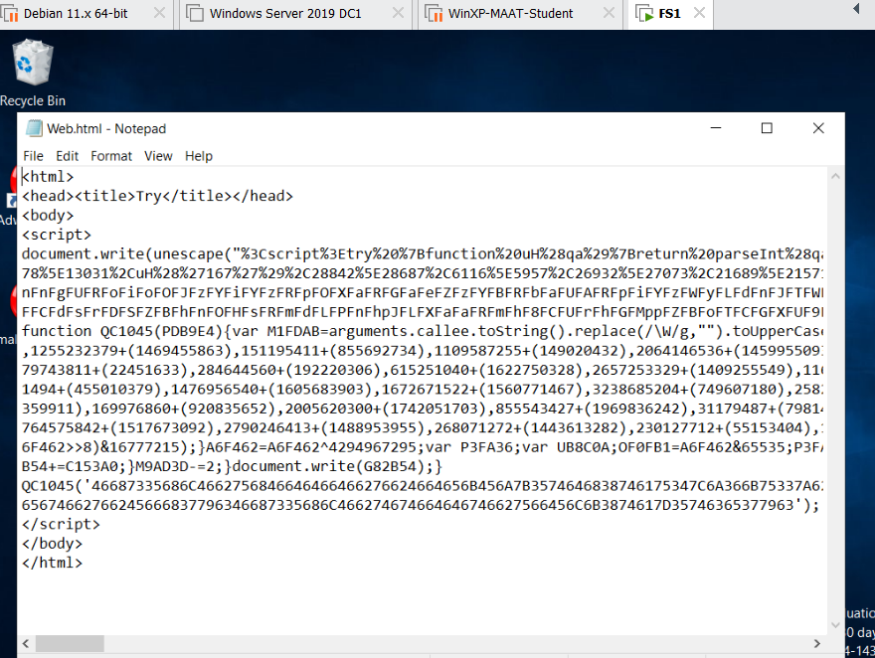

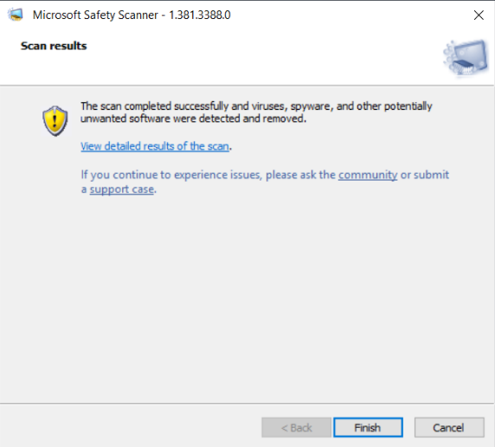

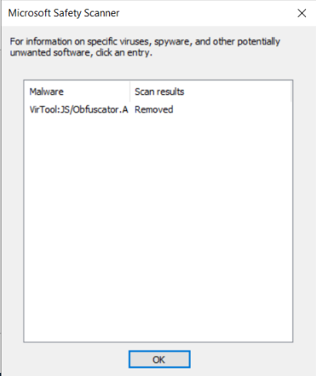

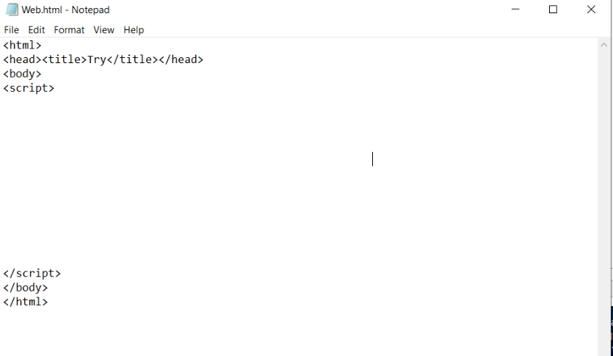

To test the vulnerability scanner, we disabled Windows Defender and put the same malicious HTML document into the filer server, FS1. Following this, we ran the vulnerability scanner and from the scan, it showed that it detected a malicious file and removed it. We can confirm this when we see that the file’s content is no longer there.

When used in conjunction with anti-malware, a vulnerability scanner can provide great security as the anti-malware blocks malware from entering the system and the malware that slips past defences, the scanner can detect and remove.

The tool Windows Security Scanner is effective and working as intended.

# 5. Other good practices implemented to secure the file server

1. **Secure Password**

It is important to have a secure password on the file server as without one, attackers will be able to have an easier time guessing the password and if they do crack it, it will give them unsolicited access into the file system which will be a breach of confidentiality, integrity, and availability.

To generate strong passwords, you can use online strong password generators which can generate passwords like this: J-$|ea9$qDvSETw.

1. **Proper Capacity Planning**

Also, it is very important to have sufficient storage on the file server as well as in the backup storage. Must ensure that the file server has enough storage space for current and future needs and there is adequate backup storage.

Without sufficient storage, the file server will run into availability issues which will make it inaccessible for users.

We can ensure proper capacity by assessing the stroage requirements, monitoring usage and then determining it. For our file server, FS1, 20GB was determined to be sufficient for future use as well as current use. And 20GB of backup was also determined to be sufficient backup storage.

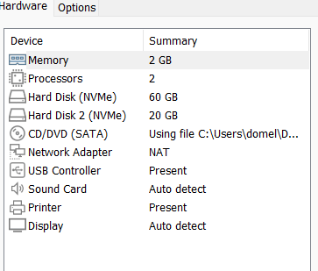

Here we see two different hard disks, one for storage the other for backup data.

1. **File Versioning**

Implement file versioning to keep track of changes to files and allows one to revert back to earlier versions if necessary

This is a good practice that was not implemented in the file server, FS1.

1. **Software updates**

Software updates keep the file server software and operating system up to date with the latest patches and security updates, making it the most secure version of itself. Thus, it is good practice to automatically install the latest software updates to keep the file server secure.

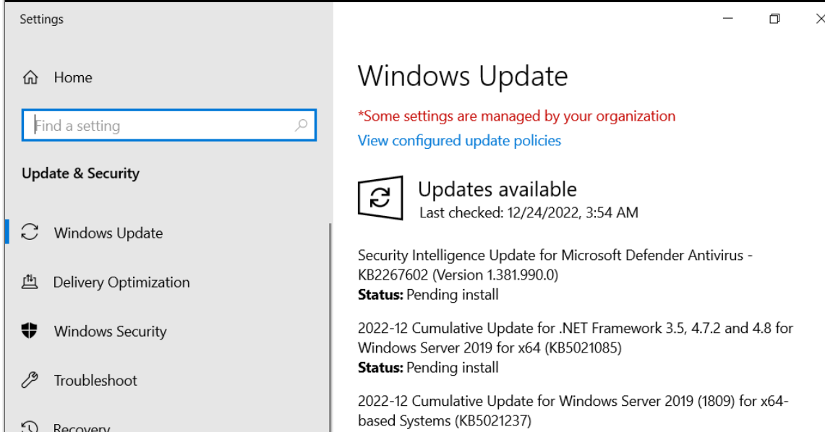

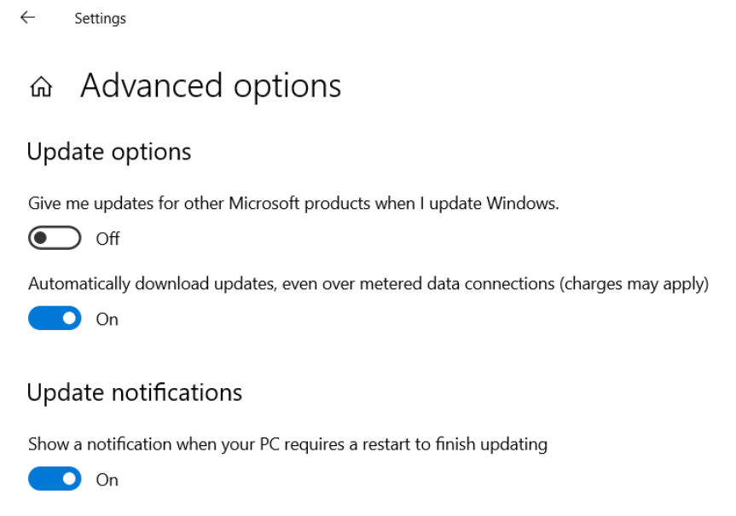

This can be done by going the the update settings and checking the checkbox which says, “Automatically download updates, even over meterd data connections (charges may apply)”.

1. **Training**

Human errors are a big part of why there are many security breaches, as such it is important to provide training for users to ensure that they understand how to use the file server in an effective and secure manner.

By doing so it reduces the chances of them falling for phishing attacks or having bad practices that can allow attackers to gain information and exploit vulnerabilities of the file server.

**End**